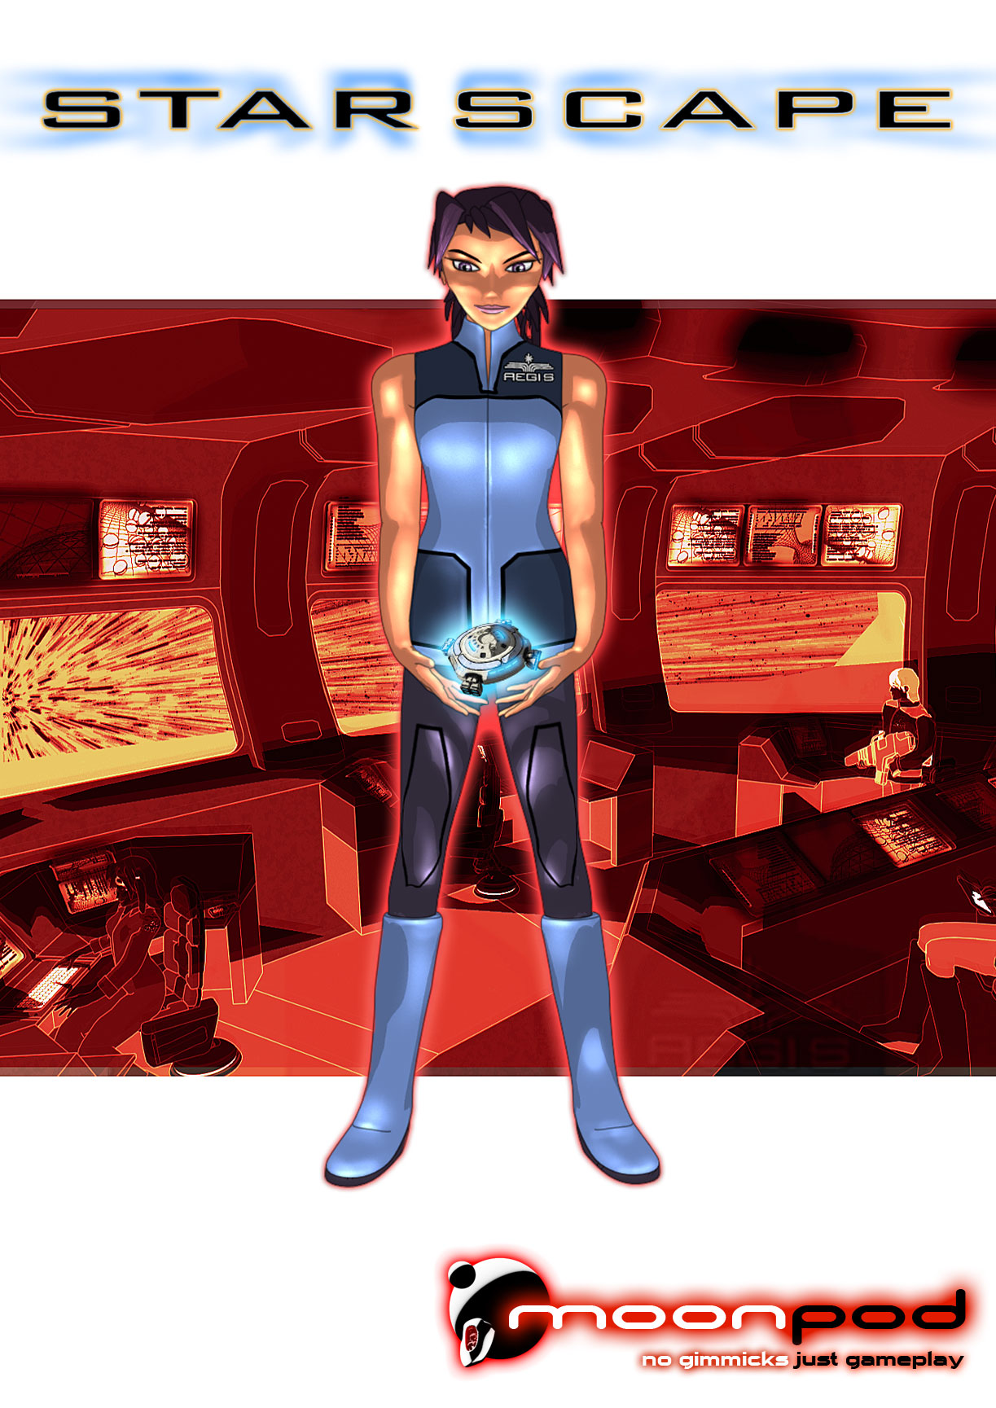

PRESS INFORMATION

Contents
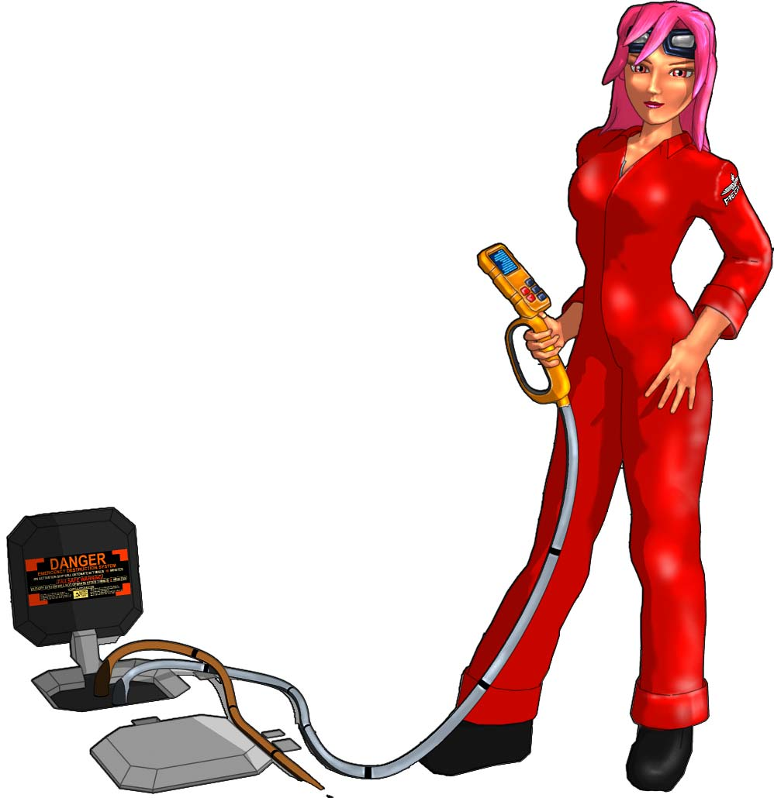
The Story 4
Design Details 6
Space Shooter 6
Navigation 7
Weapons 9
Ship Customisation 10
Research and Development 12
The Characters 15
Game Modes 16
Unique Features 17
About Moonpod 19

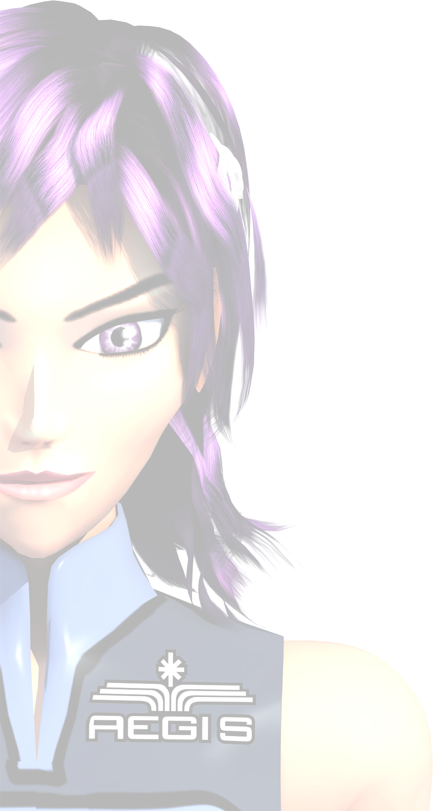

Introduction

Starscape mixes old school arcade gameplay values with RPG elements such as customisation, characterisation and involving plot to deepen the whole experience.

With most of its crew missing and its weapons systems ruined the space research station Aegis is all but lost. As the last remaining pilot you must help rebuild the station’s defences, acquire alien technology and create your own uniquely configured set of fighters. By mining the asteroids within the grid dimension, valuable resources can be harvested to fuel the Aegis’s molecular furnace to build devastating weaponry. Within the nodes of the grid you will encounter allies to aid in the struggle to escape, uncover the terrible purpose of the evil Archnid race and learn why you and the rest of the crew were brought here.

The Story
The story is revealed using cut-scenes and in-game character dialogue.
The cut-scene animations are assembled from cel-shaded image cut outs and vector shapes and use interpolation and 3D blend modes which helps keeps the file size down. The cel-shaded look is maintained throughout the front end.

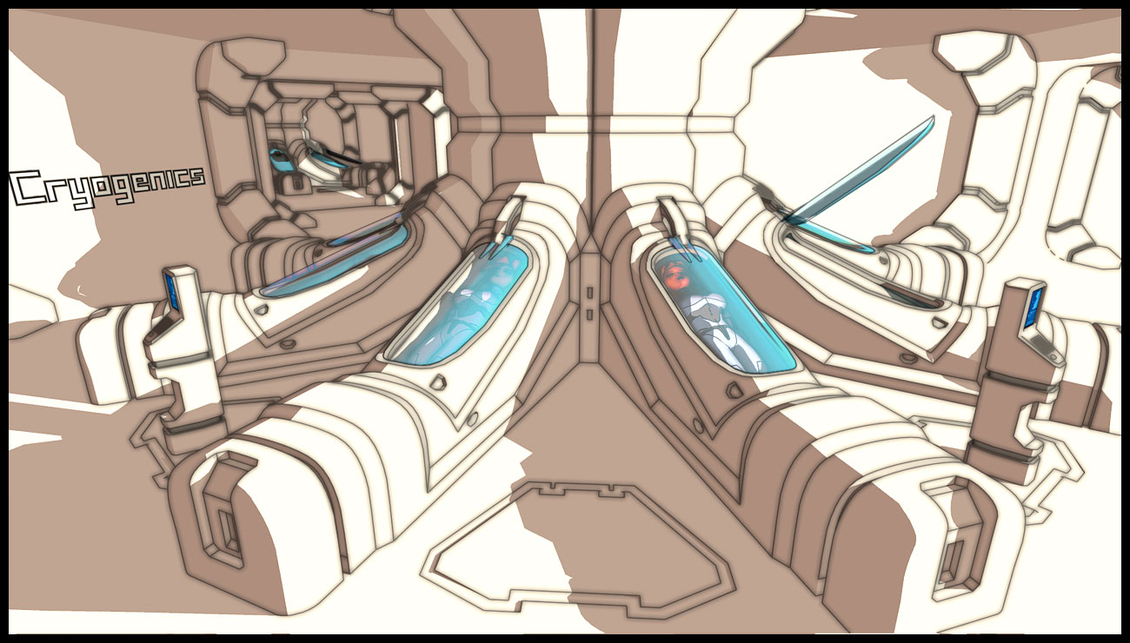

The Aegis was built as a deep space science research station to new theories in faster than light travel, based on manipulating space-time using an artificial black hole. To safeguard the Earth from its dangerous experiment, the station travelled deep into space using conventional drives for 5 years, during which the crew slept in cryogenic storage.

On reaching minimum safe distance the experiment could finally begin. As the drive began to activate, it sent out ripples in space-time. Within another dimension an alien intelligence became aware of the experiment. As the drive became unstable the Aegis and all its support vessels were pulled inside the drive and through a rip in space-time. Expecting destruction the crew were instead scattered to different locations, marooned within a dimension they would come to know as the grid. The station itself however was headed for a very specific location, an alien fleet lying in wait for their arrival. Lightly armed the station was soon overwhelmed and boarded; strangely the remaining skeleton crew were ignored.

The invaders were nightmarish amalgamations of metal and flesh, dead alien eyes staring as their mechanically enhanced legs stomped across the deck. With jerkily robotic movements and wheezing pneumatically assisted limbs they begin dismantling the station. Moving methodically they came at last to the drive room and quickly extracted the prototype dimension drive and main computer core.
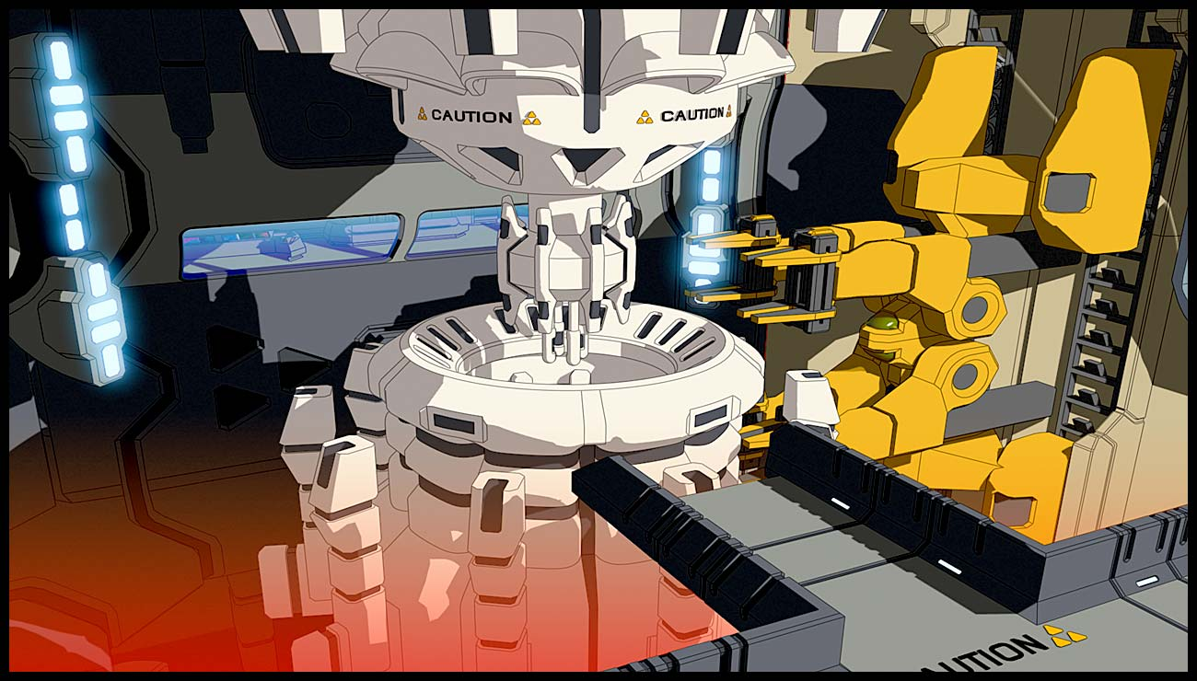

Unable to stand idly by, chief engineer Rendon attacked. Using an industrial welding torch she scythed off the leg of the nearest attacker. Devoid of emotion and seemingly without discussion, two nearby aliens stopped their dismantling efforts, disarmed the chief and dragged her away struggling and screaming.

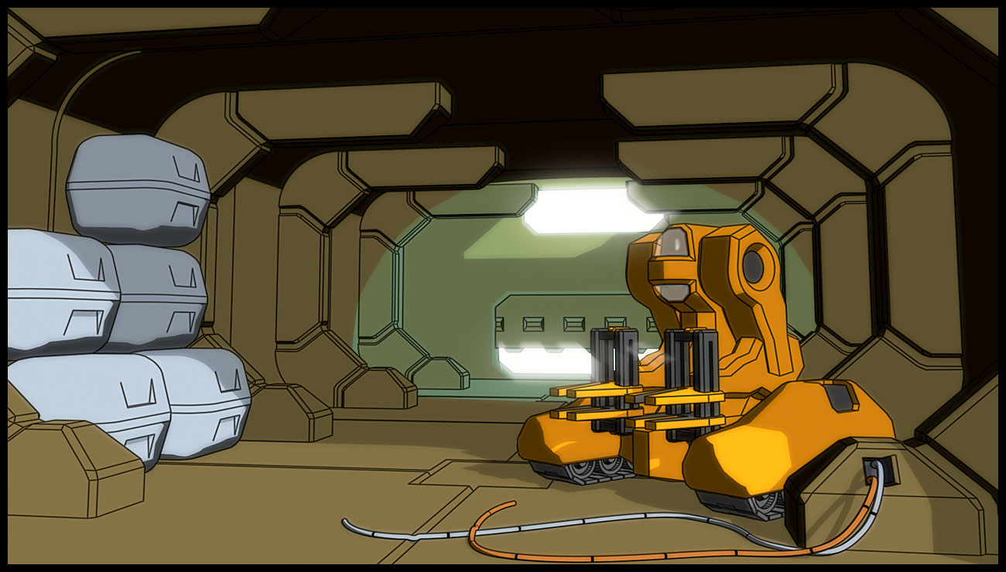

No sooner had they attacked than they had left, apparently taking only items they deemed important, the station was abandoned. Emerging from hiding the remaining handful of crew began to pick up the pieces and repair the station. Eventually they discovered the stable wormholes that the aliens had used to come and go, entering one they began to look for the missing crew. After jumping from one node to another the Aegis finally stumbled upon one of its original probe ships. Thankfully the one-man ship was still functional and contained one of the few military test pilots assigned to the mission.

You are that pilot; your adventure now begins….

Design Details
Starscape is a space adventure game built up from a very familiar and therefore accessible foundation, the asteroids style any-direction scrolling shooter. Each element of the game is discussed below in detail:

Space Shooter
The player can move in any direction using cursor keys or a game pad, he has primary and secondary fire buttons, gravity beam for sucking up items and a call button for controlling the Aegis.

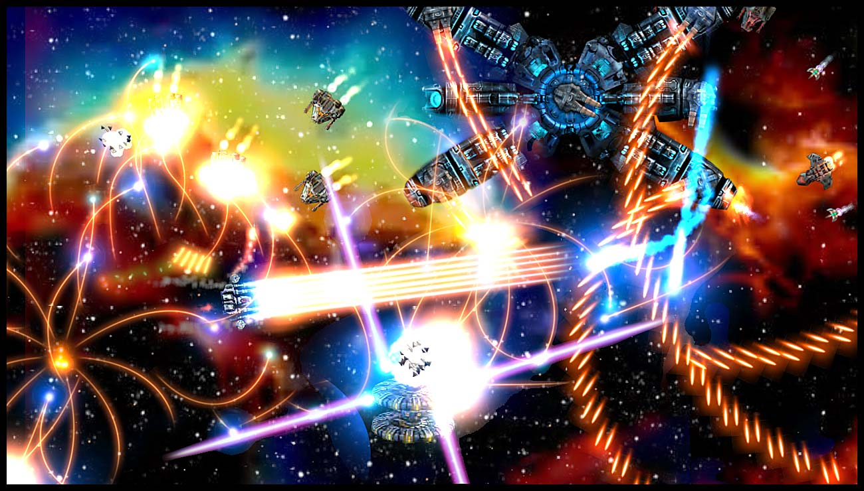

By double tapping the thrust button the player can get an extra burst of speed, useful if you need to get out of trouble. Within a node the player can move freely, his usual objective is to break up the asteroids and collect any resources within them. He is always accompanied by the Aegis, this is the space station that is the focus of the story and the player must drop off his cargo periodically.

Due to the large play area there is a radar in the corner of the screen so the player can identify enemies, asteroids and resources. There are also a series of graphs that show health of the current ship, health of the Aegis, resources gathered so far, shield strength and energy available.

Navigation
The player moves around the grid dimension on the map screen from inside the Aegis, the grid is split into five zones and each zone has many nodes. There are three levels to navigation:

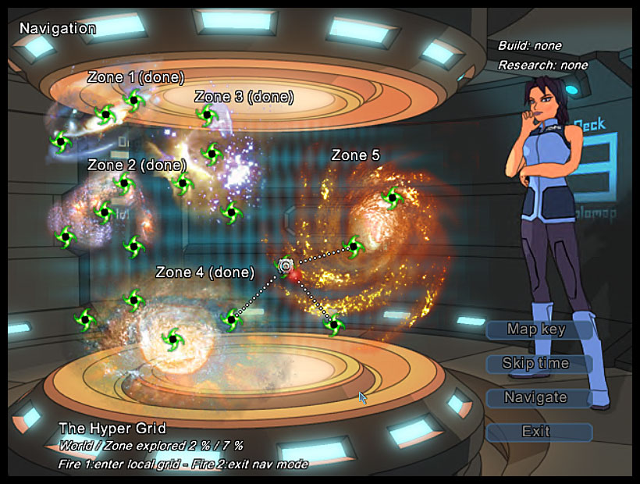
HYPER GRID: Where the Aegis can move long distances, even between zones.

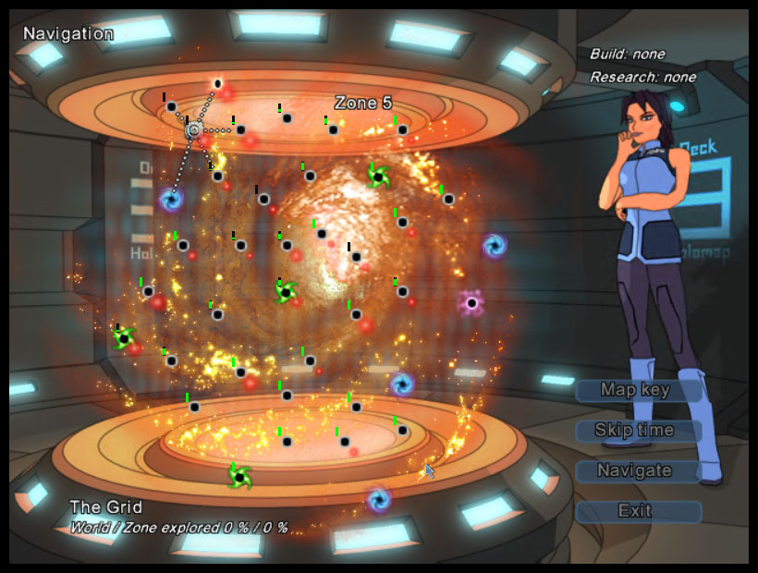
LOCAL GRID: Where the Aegis can move between nodes

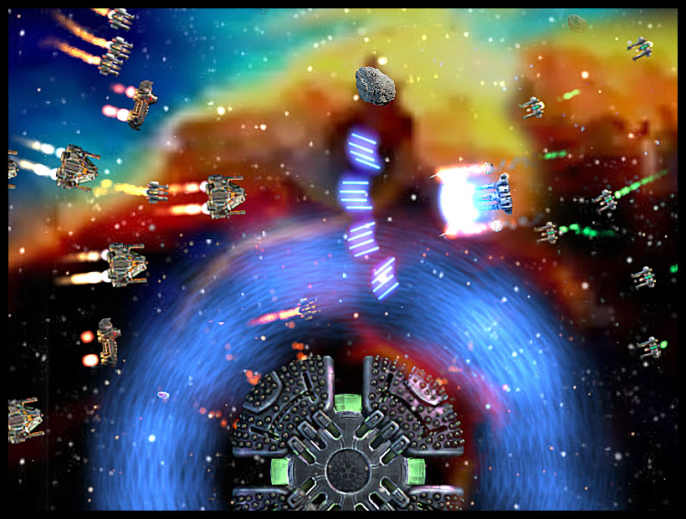
NODE SPACE: Where the player can engage the enemy and launch fighters.

As the player moves in and out of node space he uses the Aegis jump engines, these take time to charge up and can sometimes be jammed off by certain enemies. As the player skips about the zone map enemy units can intercept him and drag him into node space to fight. This adds an element of strategy to planning a route about the zone.

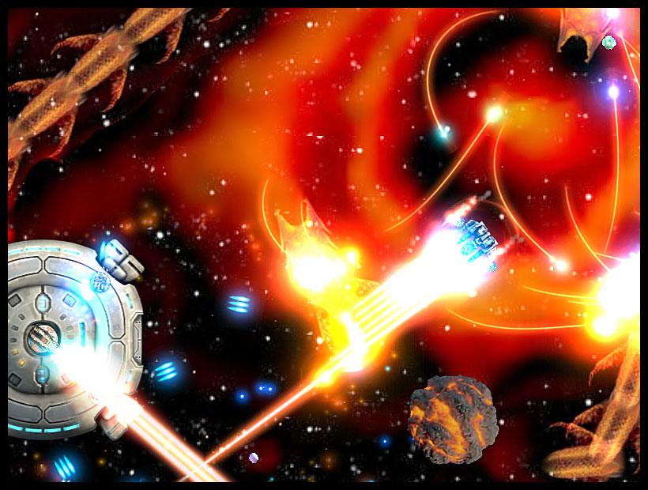

Weapons
The player can customise his space ship weapons payload and that of the Aegis, the station can often be more powerful than the player. The player’s ability to control the station therefore results in an interesting partnership not seen before in such a game. As well as starting weapons the player can get access to a new weapons technology in each of the five zones by finding and talking to the friendly alien race Xenarch.
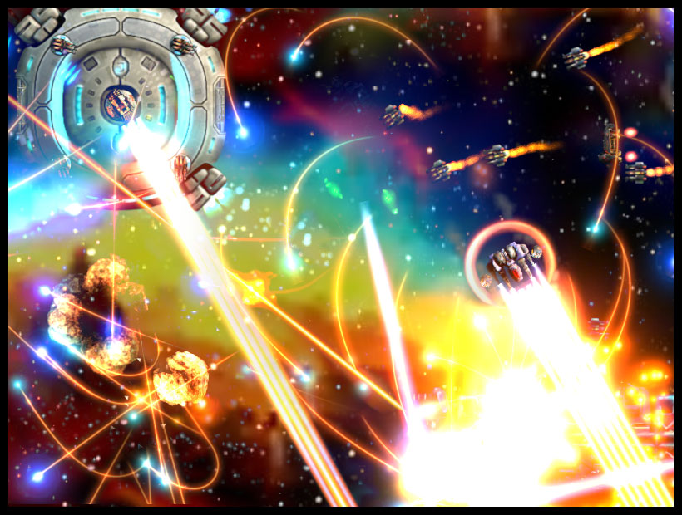

They will have either a task or trade they need before the player can get the weapons. All weapons can be upgraded using research, weapon effects become much grander as the weapon level increases.

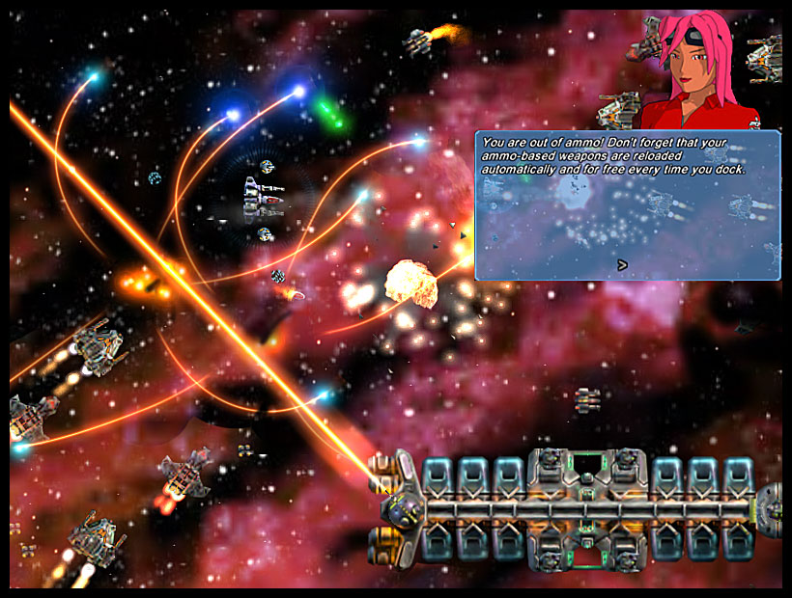

Ship Customisation

The player has three bays in the Aegis hangar; during the game he can build hulls, equipment and weapons to create up to three unique fighters. The player can also pick up equipment from the larger enemy ships left after they are destroyed. Creating a good fighter takes thought and planning, ships require a balance between power, weight and engines. If you don’t have enough power you wont be able to fire all weapons, if the ship is too heavy for the engine then it will be sluggish in flight. Each hull contains a certain arrangement of pods to accept equipment; each item to be fitted takes up a certain number of pods. The player has to spend time laying out his space ships in order to get the best use of available space.

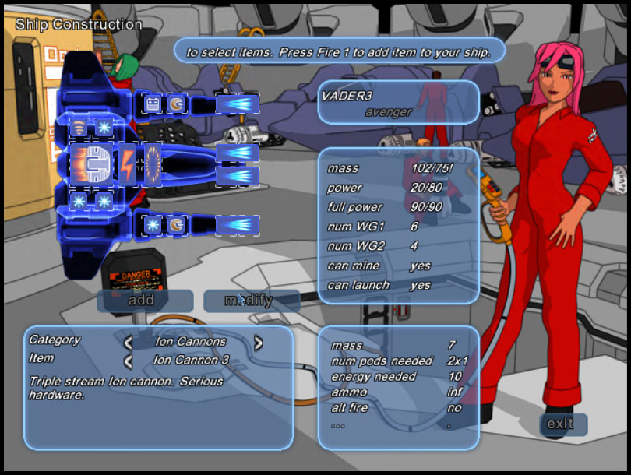

The player must research and build ship hulls for himself, there are four different hulls in the game, each can be fitted out with different weapon combinations.

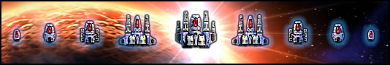
In-Game Tasks
From time to time story elements and tasks are revealed to the player via in game dialogue. The player can find outposts belonging to the friendly Xenarch aliens in each zone. He must kill certain larger enemy ships to learn of their location, once he finds them they will have some task that needs to be performed. On completion the player will get new weapons technology and more of the story will be revealed.

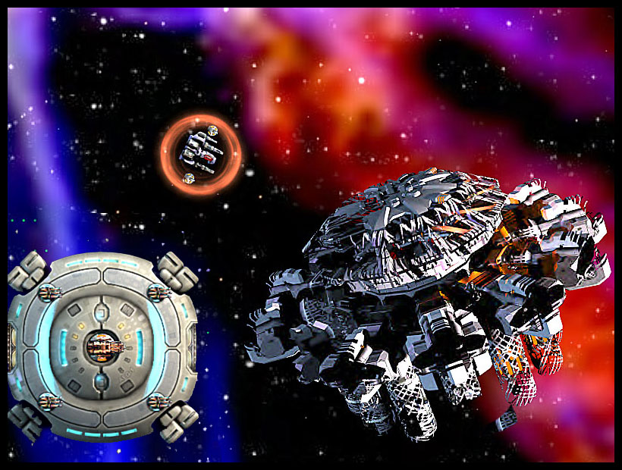

Other tasks include locating missing crew members, retrieving equipment from destroyed enemy wrecks, picking up stranded Xenarch drones and recovering pieces of the stolen dimension drive.

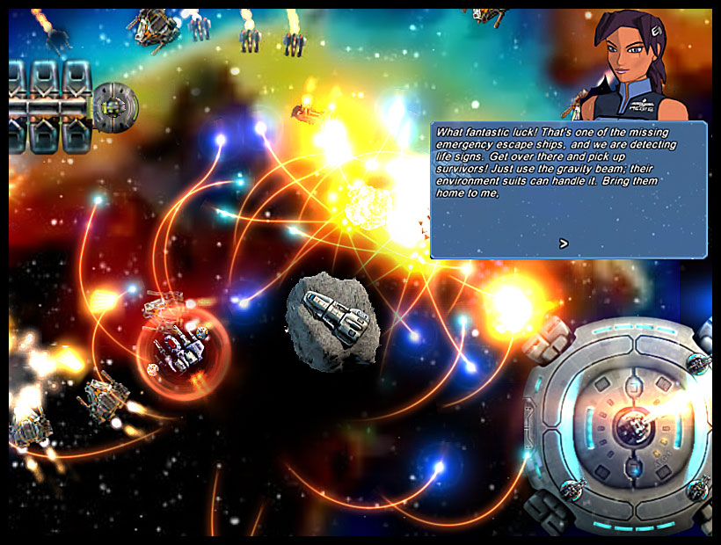

Research and Development
The player can use the recovered crew to work on research or development projects, before an item can be made the player must assign crew to research it. The more crew he finds the quicker projects can be completed. Obviously any work carried out requires resources, as well as mining for them the player can pick them up by destroying larger enemy ships or recycling unwanted equipment.

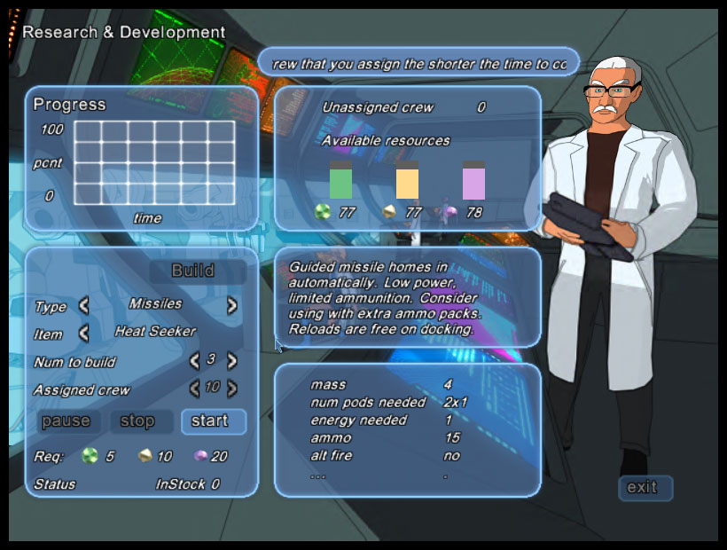

Equipment can also be picked up from destroyed enemy ships.

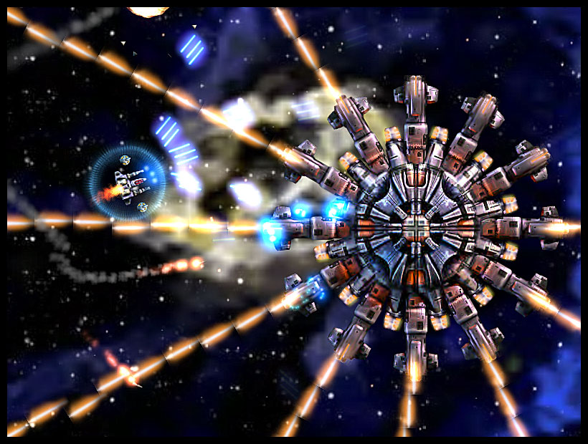

The Enemy
The enemy race known as Archnid constantly strive to thwart the player’s efforts, their queen goads and threatens the player via in-game dialog, making the experience more personal

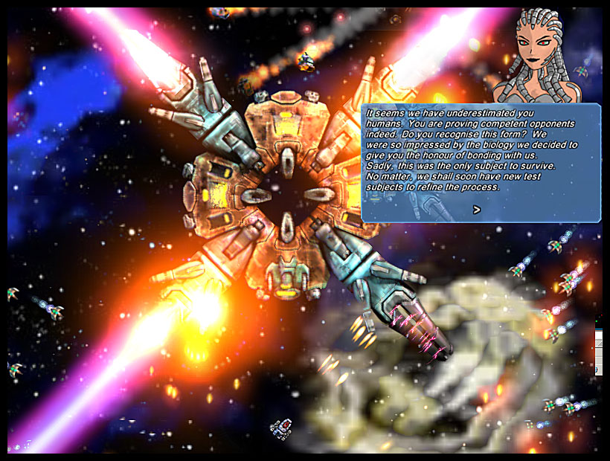

A single boss enemy controls the threat within each zone, these units are unique to each zone and very large. Enemy fighters are not created randomly, the zone boss sends out mining barges to harvest the asteroids in exactly the same way the player does. The player can see this activity on the grid map, each node has a bar next to it indicating how many resources are left in it. Mining barges show up on the map in a different colour and the bar flashes as they are actively mining.

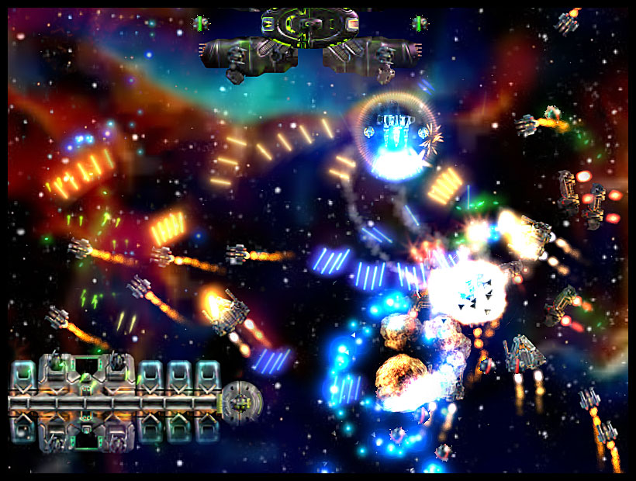

If the player can destroy these mining barges then fighter production slows, these ships also release information pods on destruction. By picking these up the player can open up the boss node, once opened the boss can be attacked whenever the player chooses.

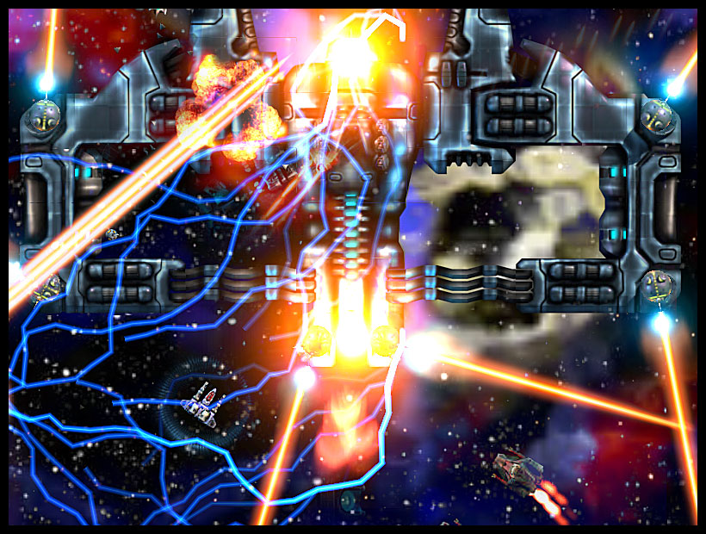

The bosses in each zone all have different strengths and weaknesses, before contact the Aegis security officer briefs the player on the best attack techniques. The boss ships are enormous, some don’t even fit on one screen and the player must actually fly inside to destroy them.

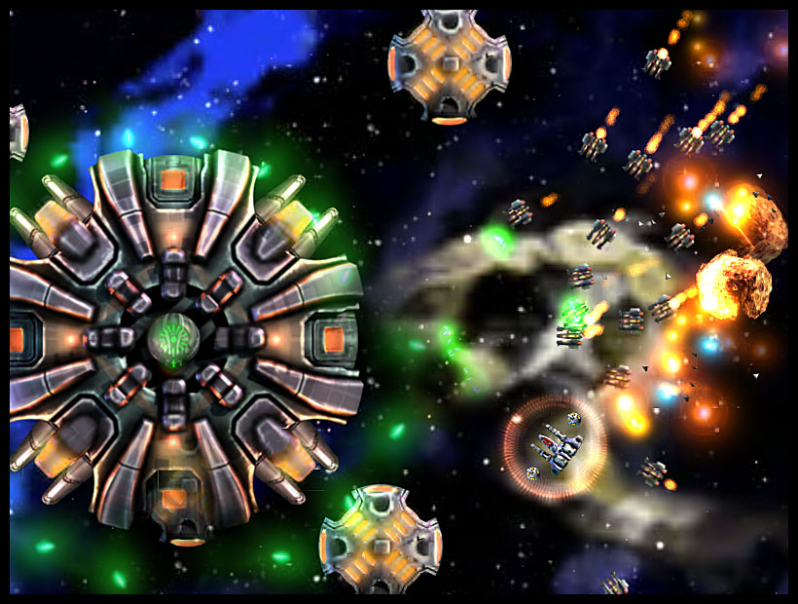
Often bosses go through stages of destruction as bits are blown off, for example the boss pictured above can have its heavy laser firing legs removed.

The Characters
The Aegis command crew provide specific help to the player both in game and in the tutorial as well as being used in the story. Each crewmember has a distinct personality and area of expertise, which comes across throughout the game.
Supporting characters that appear in game:
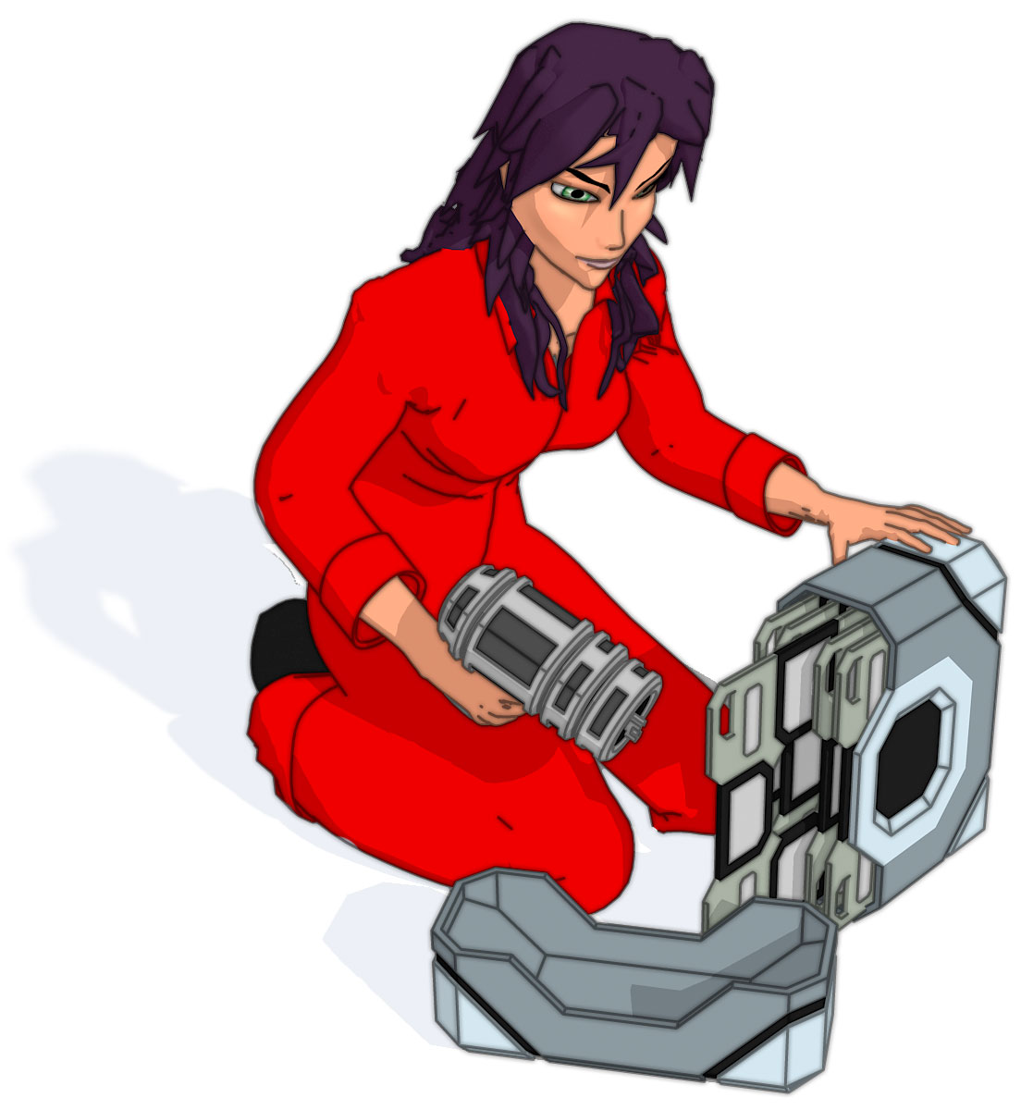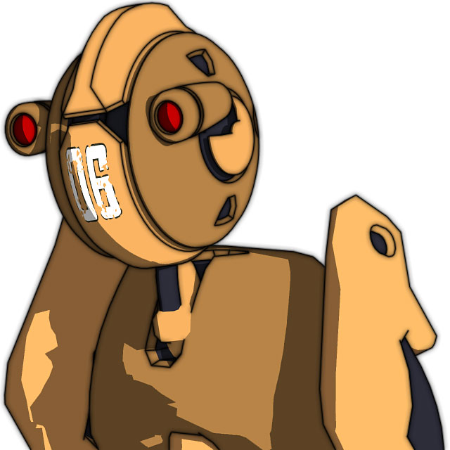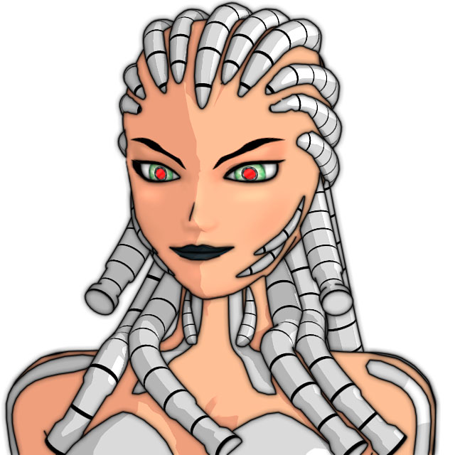
Rewards and progression
It is always important to track the player’s progress and offer rewards and recognition for achievements in game. Therefore the in-game progress screen contains a lot of information and statistics on the player’s achievements. Every custom ship the player creates must be given a unique name, the top five ships are then recorded in the progress screen along with enemies killed, time in game and whether they are still in use.

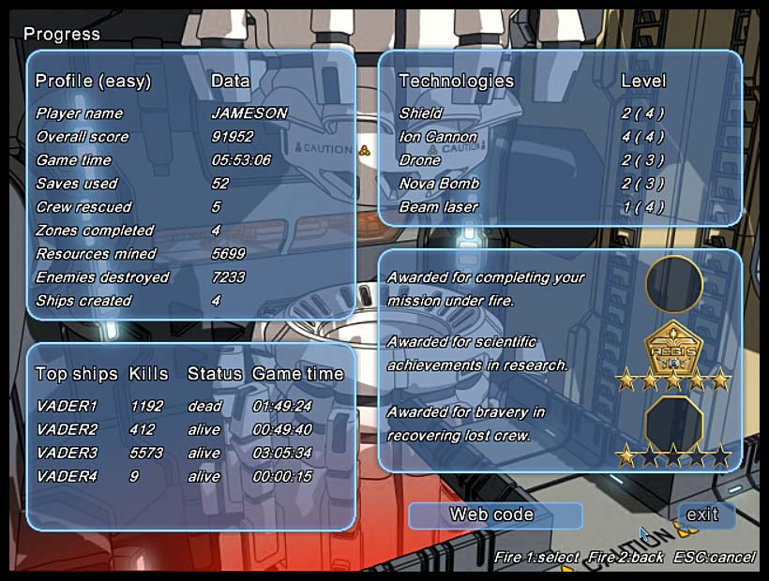

Special medals are also awarded for finishing the game, finding all the missing crew and researching all the hidden technologies.

Game Modes
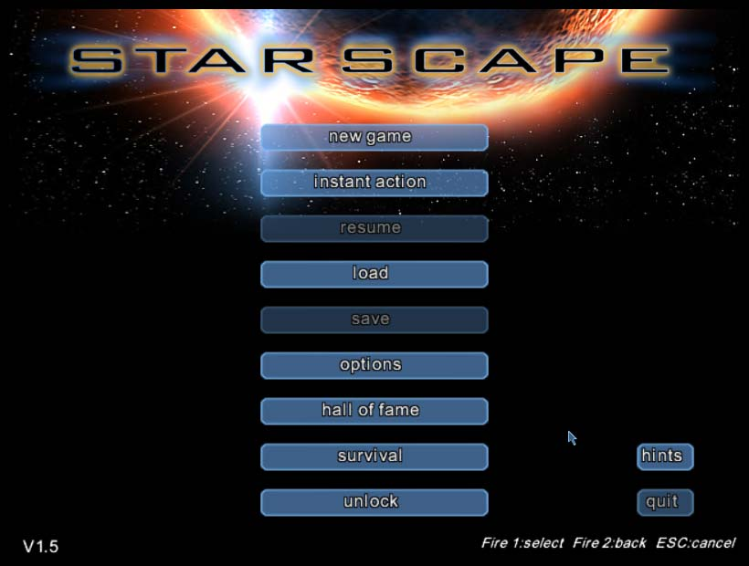

Unique Features

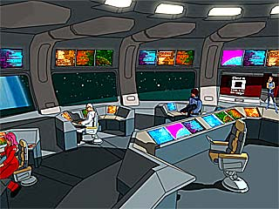
- Beautifully rendered anime inspired artwork.
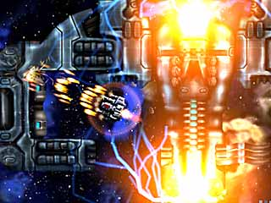
- Hardware accelerated particle effects push 2D visuals to the limit.
- Thumping music sound track and sound effects.
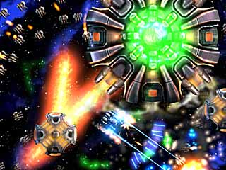
- Five different weapon technology threads to find and research.

- Five different zones to explore, only the first is available in the demo and the rest are much, much bigger
- Make alliances with friendly aliens and trade technology.

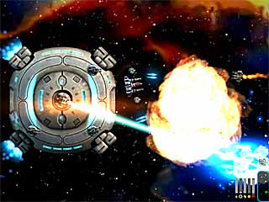
- Direct and protect your space station as it fights alongside you.
- Create your own “garage” of unique space fighters tailored to your own specifications.

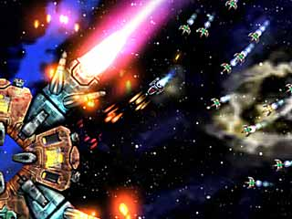
- Mine the asteroids, gather raw elements, research new technologies and build new items.
- Recover the missing drive components and rescue your missing crewmates before escaping “The Grid”.

Reviews
  Game Tunnel | "I only had enough speech capacity to say, 'Wow.' "  "you can also play the game again... and again"  "..soundtrack is first-class."  "..design for each sprite is fantastic"  Winner of 2 Game Tunnel Awards:  *Adventure Game of the Year*  *Independent Game of the Year* | 10/10
PC Gamer Magazine  UK, May 2005 ed. | "The light that burns bright may burn half as long, but you, my little beauty, have burned so very, very bright."  "It's worth buying because it's a cracking little tactical shoot-'em-up; it’s jolly good fun;" | 80%
Games Xtreme | " immensely enjoyable"  "stuffed to the gills with playability" | 93%
  Netjak | "3D effects you would expect from a top of the line space sim"  "This is old school goodness through and through. I suggest anyone who likes shooters or anything to do with space give this game a shot. You shall be impressed. " |   9.2/10
 | "The graphics and presentation could not be better"  " Watching your fully operational battle station take on the alien hordes automatically is a wonderful sight to behold" | 91%
  Game Chronicles Magazine | "one of the best little known titles I’ve run across"  "backgrounds of all the 'zones' you explore are awesome"  "one of the best game soundtracks I’ve heard in a long time" |   9/10
Static Gamer | 'Starscape is a title that shows great games can still be 2D'  'Deeper than your run-of-the-mill space shooter'  'Where Starscape really starts to take off is in the game play' | 
Gaming Invasion | '...innovative yet sticking to tradition'  'Starscape is simply stunning and excelling'  'it looks good, real good' | 80%
New Straits Times | 'The best looking 2D shoot-em-up that I have seen'

About Moonpod
Founded by three games industry console developers with more than 20 years combined professional experience. Brought together by the desire to create innovative, original games based squarely on pure game play and heart stopping action. Moonpod has gone back to its roots. The company ethos is to bring mainstream high street quality values to direct download fun games. By getting back to the original concept of cheap, fun games with a price that leads to impulse purchase Moonpod hope to reach an emerging market of starving gamers.

http://www.moonpod.com/

