

Contents

Contents 1
History 2
Location & Contact Details 2
Games 2
Development History 3
Interviews 4
Gamesxtreme 4
Gamershell 6
Bytten 8
DIY Games Picture Story 10

History
Founded in 2002 by three games industry developers with more than 25 years combined professional experience. Brought together by the desire to create innovative, original games based squarely on pure game play and heart stopping action. Moonpod has gone back to its roots. The company ethos is to bring mainstream high street quality values to direct download fun games. By getting back to the original concept of cheap, fun games with a price that leads to impulse purchase Moonpod hope to reach an emerging market of starving gamers.

Location & Contact Details
Moonpod is located in Sheffield in the UK.

Moonpod Ltd.
43, Richmond Rd
Handsworth
Sheffield
S13 8TB
UK

Phone: +44 0114 269 4185
Email: info@moonpod.com

Directors: Mark Featherstone, Nick Tipping.

Games
 | Mr. Robot  A 3D action/adventure/puzzle/rpg, inspired by classic filmation games such as Knight Lore and Alien8.  OUT NOW ON PC!
 | Starscape  Starscape mixes arcade game play with characterisation and involving plot in this space shooter/strategy game.  OUT NOW ON PC!

Development History
Each member of the Moonpod team earned his stripes during many years of work in the mainstream games industry. Included here is a list of all the published games that each team member was involved in.
 | Gun Metal  Arcade shoot’em up for the Xbox and PC, released by Rage Games.
 | Totaled! / Crash!  Destruction derby style arcade car game for the Xbox, released by Rage Games.
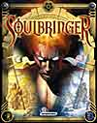 | SoulBringer  Fantasy role-playing game for PC, released by Infogrames.
 | N2O  Arcade shoot’em up for the Playstation 1, released by Gremlin Interactive.
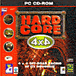 | Hardcore 4x4  Off-road racing game for PC, Saturn and Playstation 1, released by Gremlin Interactive.
 | Judge Dredd  Light gun shooter for the Playstation 1, based on the popular comic strip, released by Gremlin Interactive.
 | Actua Soccer 2  Sports simulation for PC, released by Gremlin Interactive.
 | Actua Tennis  Sports simulation for PC, released by Gremlin Interactive.

Interviews

Gamesxtreme
10th July 2004
Original article link: http://www.gamesxtreme.net/pc/game/starscape/interview-1863.shtml

Games Xtreme recently got the chance to ask the Moonpod team about their first game, Starscape, plus a little about the people who created it.

GX: Please tell everyone your name(s) and position(s) within Moonpod.

Mark Featherstone - game programming
Darren Griffiths - engine programming
Nick Tipping - artist

GX: Moonpod is a shareware company made up from members of the industry; can you tell us some of the games you have worked on collectively in the past?

Gun Metal, Totaled! / Crash!, SoulBringer, N2O, Hardcore 4x4, Judge Dredd, Actua Soccer 2, Actua Tennis.

GX: Everyone has a different view on what makes a good game, but what in your opinion makes a great game?

A game is a mixing pot of many elements, some more important than others, good games get a few elements right, but truly great games manage to acheive the same level of quality across all those elements. I'll play almost anything that consistently delivers across the board, here is an ordered list;

1.gameplay - if it doesn't have that elusive addictive quality then forget it
2.visuals - like it or not games are a visual medium, they just have to look great
3.user interface - if you don't know what to press, if you can't control it easily then it is just bad 4.sound and music - very important to add the right atmosphere
5.setting, story, plot and characterisation - it must have something to make you feel part of it, to suck you in
6. USP - unique selling points, what does this game do that is totally new, cool or just different

GX: Can you remember the last time a game really surprised you (either technically or emotionally?)

The first time was 3DMonsterMaze on the ZX81, I was playing it in the dark and was really scared, it kept making me jump out of my skin. The last time was C&C:Generals when the dam blew up and the rushing water swept away the enemy, that game just looks really cool.

GX: What are your favourite genres, can you give some examples of games from these genres that have inspired you as developers?

1. Wolfenstein, doom, quake series - always cutting edge, gorgeous and always addictive
2. Cune2, C&C, Starcraft, Warcraft, Total Annihilation - evolved and refined the RTS genre, always high quality
3. Half life - a fps with gameplay and depth (eek!)
4. Civilisation - shows that less action and more thought can still be amazing fun
5. Elite - what a fantastic idea, you ARE Han Solo, shame nobody has managed an update that captures the same feeling
6. Zelda and FFX - rpg heaven

GX: What were the goals you set yourselves when setting up Moonpod?

We wanted to stop chasing the curve i.e. getting that next movie/sports licence, increase the same old feature list, add another 5 men to the 30man team and extending the development time another year. We just wanted to see what 3 people can do in less than a year, that way we get to make more than one game before we retire and keep everything focused on just making it fun.

GX: Starscape is your first game, how did the development process go for you, has the game turned out as you had originally planned?

Mainstream industry is filled with canned projects, feature cuts, constant staff turn around, 2-3 year developments and disappointing finished games. Having 3 people and less than a year fundamentally affects development, accepting these limited resources actually improves the end product. The original paper design for Starscape is fully realised in the actual game, we slipped by just a few weeks and no major features were cut. That is unheard of in mainstream development.

GX: Are you pleased with the response Starscape has received from the public?

Our forum contains a lot of praise for the game so we are very happy, everyone seems excited and wants more and I think that is a good sign.

GX: What are your plans now that Starscape has been released are you going to expand upon it or work on a different game?

We have started work on a new game, this time it is a RTS and again we are trying to focus on the core gameplay, what actually makes those games fun, the actually strategy and battle element. Boil the genre down to the essentials, wrap it up in a good-looking package and hopefully get another fun game at the end.

GX: Will you stick with designing in 2D or you have ambitions for 3D?

A 3D engine is in development for use with our third game out towards the end of next year.

GX: How has your experience of Shareware been? Is it a business model you're happy with?

The problem is exposure; if people don't know about you then they can't buy your game, simple as that. There is a traditional large shareware market for puzzle and cheap games, nothing wrong with that but we need to differentiate ourselves from it. There are a small number of shareware titles out there that are actually aimed at normal gamers, usually slightly more expensive and with high production values. Problem is that normal gamers still associate shareware with puzzle games and low quality; it is also very difficult to get reviews or placement on mainstream sites.

GX: Has your publication via Shareware been a statement about the pricing of new releases or has it been about the independence of self-funded development?

Both I think, self-funding releases us to develop simpler games quicker, as soon as you can do that you can start to take risks and try new things. With a 30man team and 3 years to develop a game it is business suicide to take any kind of risk and this is why you see so many sequels and licensed games.

GX: Would you consider developing directly for a publisher or working with a publisher to facilitate a more widespread distribution of your software?

Absolutely, a publisher is still the only way to get your game to the mass market; I wish the Internet would catch up so that wasn't the only way. It isn't just the publisher either, it is advertising and that costs money, lots of money. You have to do whatever you can to get your game under Joe Average's nose; he can't play it if he doesn't know about it.

GX: Any final words on Starscape?

Starscape is great fun! If you don't believe me then go ahead and download the demo, it is absolutely free. We even give people their money back if they buy it and then later decide they don't like it, can't say fairer than that.

GX: Any final words in general?

Support independent development, it is the last bastion of innovation and creativity!

Gamershell
Original article link: http://www.gamershell.com/articles/634.html

Hi, please introduce yourself and your company to our readers.

Moonpod is an independent game development company created by three game industry veterans. We have just finished and released our first game Starscape. The company founders are:

Mark Featherstone: game programmer
Darren Griffiths: engine programmer
Nick Tipping: artist

For those who don’t know Starscape, could you fill them in on what it is, its story etc?

Starscape is a space action/adventure game with a few rpg(ish) elements thrown in for good measure. The background is that you are a member of the Aegis crew, a science research space station built to test theories of faster-than-light travel. Due to the inherent danger of the prototype FTL engine the station has to travel out into deep space before testing it. The dimension drive manipulates space-time using black hole theories and when activated is detected by beings trapped in another dimension. These aliens interfere with the experiment and the Aegis is pulled through into the “grid dimension”.

During the process most of the crew try to abandon ship and are also pulled through and flung to all corners of grid space. The aliens are lying in wait for the Aegis and immediately attack, parts of the station are stripped including the irreplaceable drive prototype, and the station is then abandoned. The command staff still hiding aboard the Aegis make repairs and manage to find one of the escape craft and a single pilot, the player takes the role of that pilot.

Your job is to refit the station for war, find the missing crew and hunt down your alien attackers to recover the missing dimension drive. Along the way you encounter friendly aliens, uncover the story of the grid dimension, it’s nastier inhabitants and even bump into some rather strange worm-like life forms that live in the grid.

How did the idea behind Starscape come about? What games, movies, or literature inspired you?

We were all a bit “damaged” from working in the mainstream games industry; it can make you a bit cynical about games after a few years. We wanted to cut our ties and start again, go right back to our roots, start really simple, just make things fun and see what happens. We wanted to take a simple familiar game mechanic, something people would definitely “get” instantly, but then build on that foundation with all the complimentary features that go to make a great game. This is how the process kind-of went:

- Theme - Sci-fi: No particular reason for this theme other than we are all sci-fi fans.
- Basic mechanic: Asteroids. Needed to be familiar enough so people immediately understood at a low level what was going on. There is enough to think about in the game, the basic mechanic must be obvious and compelling.
- Back-story: Lost in space, Babylon 5, Voyager. It was important to get this in early as it fleshes out the characters and gives meaning to the game, it helps define early on what you are doing and why. It also helps direct the look and feel of the game and gives it direction. We wanted something where it wasn’t always clear who the good guys were, something where the enemy had a reason for their evil ways, where the crew themselves were sometimes in conflict.
- Open structure: Don’t force people down one route. There is nothing wrong with linear games when done for a specific reason i.e. to create a specific fixed experience, but we love games that let the player decide the pace and give him the freedom to explore.
- Visuals: It has to be beautiful. Regardless of what people say games are a visual medium and they just have to look good, no two ways about it.
- Game play: It has to absorb the player. Got to have lots of action, as Neo would say “guns, lots of guns”, shooting can get old though unless you add depth with more long-term features. We added fairly straightforward elements like resource gathering, exploration, reward driven in game tasks, customisation and upgrading.
- Sound: The music has to be fast and the explosions loud. We used quality speed techno tracks, as a result we couldn’t have as many as we would have liked, but quality is better than quantity.

All three of you guys have certainly been around for some time in the game development industry, so going from large-scale projects to something considerably smaller must be an odd experience. How did the project management differ compared to a more “full-scale” game?

It was very similar, just in micro, we still had monthly milestones, milestone review, documented schedules and detailed design documents. Having three people instead of 20 meant communication was a lot easier, meetings went faster and everyone was a lot more productive. As a team grows it is a fact that productivity falls, sad but true, people lose site of objectives, more meetings are needed to keep everyone on track, quality can slip as people have different objectives, upper management types become involved, etc.

What went right during the development, what could’ve been done differently, and what lessons were learned?

We reduced our aim to something we could realistically achieve, this is one of the biggest mistakes developers can make. It’s easy to design games, just gaze out of your window and think of all the great games you’ve ever played and start writing down all the little things you enjoyed. In the end you will undoubtedly have a recipe for the best game ever, problem is you will never realise it (unless you are Square, Valve or id).

A real design looks at the people on the team, realises what they do well and the time they have and then creates something whole (holistic design?), that pushes the staff to the limit but no further. This is the first time I’ve worked on a game where the final product actually looks like the game described in the initial design.

One thing that would have helped would have been to involve the Internet community in testing at an earlier stage as well as hiring more dedicated internal testers earlier. We over-ran our schedule by a few weeks due to late feedback from testers. It is unavoidable that developers get too close to their games, it is essential to get neutral feedback from real people as soon as is practical. You must also never underestimate the variety of hardware that can go into PC’s, we ended up having to buy in lots of weird and wonderful equipment (video cards and input devices) at the end of the project and had to do an early patch for compatibility.

So far, are you happy with how Starscape has been received?

We receive a lot of very positive feedback on our forum daily and it’s very gratifying, we put heart and soul into Starscape and it’s good to see people enjoying it. One of the big problems for us is that it is very frustrating just bringing the game to people’s attention. There aren’t many websites out there that will talk to independent developers, especially when they haven’t made the next 3D third person large breasted action game. Luckily gamershell isn’t so blinkered!

Did anything particularly funny happen during the development?

When we first started we were working out of a converted back room at Darren’s house, it didn’t take long before we were working long hours seven days a week. An unforeseen side effect was Darren ended up never leaving the house for days at a time. One day we came in and he didn’t seem to know what day it was and had locked us out. We had to smash a window eventually and found Darren hiding behind the settee brandishing his ornamental samurai sword. It took a few hours to “talk him down” and we had to spend the day in the park “getting back to nature”.

If you did have the resources and manpower of a large-scale game, what changes would you make to the game?

Multiplayer was rejected early so we could focus on core game play, which was the right decision at the time. With more people we would have added an online element to the game, it is something a lot of fans ask for and would be a great feature. More staff would also have allowed for more variety in enemy units and scripted in game tasks.

I would assume you guys have already begun working on a new game. Could you give us some titbits of info? Is a sequel a possibility?

Our next game will be based on a strategy battle game idea we have wanted to try for a long time (another idea that wouldn’t have been possible in the mainstream industry), this one will shift the focus right over into multi-player too, and we thought it would be fun to set it in the Starscape universe. We certainly haven’t ruled out the possibility of a sequel to Starscape in the future though, our initial design even planned for one that went far beyond the original, so it may be something we come back to.

Is there anything else you’d like to add?

Independent developers help take gaming in new directions, perhaps games you wouldn’t see today from the mainstream, but might tomorrow. Most independents are small and use free demos to sell themselves, life is hard for an indie, demos are free so show your support and give it a try.

Bytten
6th June 2003
Original article link: http://bytten-mas.blogspot.com/2006/04/moonpod-interview.html

Starscape is the impressive debut from Moonpod, An A-Team of industry professionals who decided to take the indie route.

The game is a shoot-em-up with resource finding and research elements, as well as a good plot and excellent graphics and presentation. With a review due here in a few weeks, we caught up with the team to ask them about the game.

The Team
Nick Tipping: Art.
Darren Griffiths: Engine programmer.
Mark Featherstone: Game mechanics programmer and game designer.

How did the whole project come about?
Moonpod: We had talked about setting up our own studio for a long time (most developers do), one of the problems was the small team size, it would take us far too long to get the next all singing and dancing 3D engine up and running. We looked into the whole independent/shareware scene and realised there were a few gems out there, games small in scope but big on fun, and at that point we started looking for game ideas that were within our reach. There are a lot of indie games that promise the earth, but we'd rather see a game reach a high overall level of quality that approaches/matches that found in high street games.

How long did Starscape take to make and how much planning went in?
Moonpod: The project took 8 months from start to finish, coming from mainstream development we had plenty of experience with the normal development process. The only difference here was that the reduced scope of the game let us condense the time line from two years to 8 months. That said, it was still a mammoth undertaking, 7 day working weeks and 16 hour days.

You've worked on full blown commercial titles. How different is indie development and what are the pro's and con's to each?
Darren: I'm happy no suits talk to me, but I don't have as much money to spend on useless gadgets anymore!
Nick: The main difference for me is I'm an art team of one, so I have to do everything. It's great though because every day is different, there's no production line mentality, and I don't waste half my day explaining to management why a particular unit looks like it does! I do miss having other artists to bounce ideas off, but luckily Mark and Darren are pretty good with feedback.
Mark: Yes, you have to wear a lot of hats with indie development which is interesting but also tiring. With a small team communication is instant and direct, when the team size is 10-20 then it takes a lot of work just to keep everyone motivated and moving in the right direction. The lack of higher management lets us respond more quickly to changing conditions, we don't have to wait a week for a decision. Managers, producers and directors tend to form committees and distance themselves from development somewhat. As a result mistakes can be made because the people in control are balancing 5 different teams or just don't have the right familiarity with your specific game.

There aren't many games that combine 2D shooters with space conquest games, what were the influences on the game idea?
The cartoon graphics reminded me of UFO/X-COM.
Mark: Yes I was a big fan of the X-COM series, inspiration for gameplay came from games like Star Control 2, Sinistar and Area88. I love it when a game takes simple familiar fun themes i.e. shootemup's, but then widens and deepens the experience with plot, characterisation, customisation and exploration. I think the ability to customise and freely explore are plus points in any game, another favourite of mine and good example being Syndicate Wars.

There's a cartoon look to the cutscenes and characters, were these sorts of graphics easier or more difficult or more fun to produce than the more conventional bitmap graphics and textures?
Nick: We wanted to introduce the story via animation, but video would have drastically increased the download time. We looked at techniques used by cart based games that were also limited by memory, in particular, Snes games like Metal Warriors. This prompted Darren to write a 2D animation tool, for recording sprite movement and playing it back. As a bonus he exposed all the sprite renderer's features to animation, like nice screen blend modes available on modern 3D hardware.

The look of the cut scenes and characters had been something I'd been experimenting with for a few years (I was originally looking for a way to spend more time working on character expression rather than photo-realism) However, I'd not been able to convince anyone to use the style in a game. Starscape seemed like the perfect opportunity to try it out. It was a bit of a gamble, but it seems to have been successful, judging by the number of fans JJ (the female mechanic in the game) seems to have acquired!

Which aspect of the game is each of you most proud of?
Nick: The front end backdrops are my favourite. I love clean edged art (probably because I'm quite a messy artist with traditional media), but I wasn't sure anyone else would like the style. After Starscape was released, we were inundated with requests to make desktop wallpapers available, so I added some to the customer section of our site, and we all have mousepads with them on too!
Mark: In the mainstream games industry part of my job was to monitor and maintain the overall quality of the game with a focus on the programming content. I think there are a lot of games that have great sound, or fantastic graphics or good gameplay, but rarely does a game manage to maintain the same level of quality across all elements. A game is made of a lot of separate parts i.e. graphics, gameplay, plot, sound, user interface, etc and if you drop the ball on any of them you ruin the overall effect. As an indie development I was particularly worried about this with Starscape, but I'm proud of the high quality of implementation we managed to achieve across the board. Oh and I also think the partnership between fighter and space station is a pretty unique and cool feature.
Darren: That the game was completed to such a high level of quality, in all areas, in such a short time scale.

What are your top favourite games of all time, on any platform?
Nick: Elite (not Frontier!), advance wars on GBA, Speedball II on the Amiga. RanaRama on spectrum! Bomberman.
Mark: GTA3ViceCity, FinalFantasyX, StarControl2, Elite, UltimaOnline, Wolfenstein/Doom/Quake, Ultima Underworld, Zelda, Goldeneye, SyndicateWars, Starcraft, Diablo, Dune2, Castelvania, Halo, Unreal, Command&Conquer, 3DMonsterMaze.
Darren: Head Over Heels - Spectrum, Elite - Spectrum, Escape From Monkey Island - Amiga, Quake 3 - PC.

Finally, what future plans do you have?
Moonpod: Work is already underway on our second game which should be out later in 2003, it is probably going to further develop the Starscape world and characters, but wont be a shootemup. We may come back and do a Starscape sequel at some point though. As our success continues we hope to develop our studio, take on a few more developers and expand the scope of our games.

DIY Games Picture Story
5th September 2003
Original article link: http://www.diygames.com/index.php?p=298&more=1

Less than twelve months ago almost no one knew who Moonpod was, and now they seem to be everywhere, at least their advertising is. The group hit it big with their first game as an indie outfit, the critically acclaimed Starscape, and they've already got a more ambitious project in the works. While you probably won't see them on the cover of Computer Games Magazine anytime soon, don't be surprised to find them and their games mentioned in the mainstream gaming media more often as time goes on. Until then, take a tour with the Sheffield boys as they show you their work area, the sites of ECTS, and the local night life. Parents, cover your children’s eyes, this could get rough.

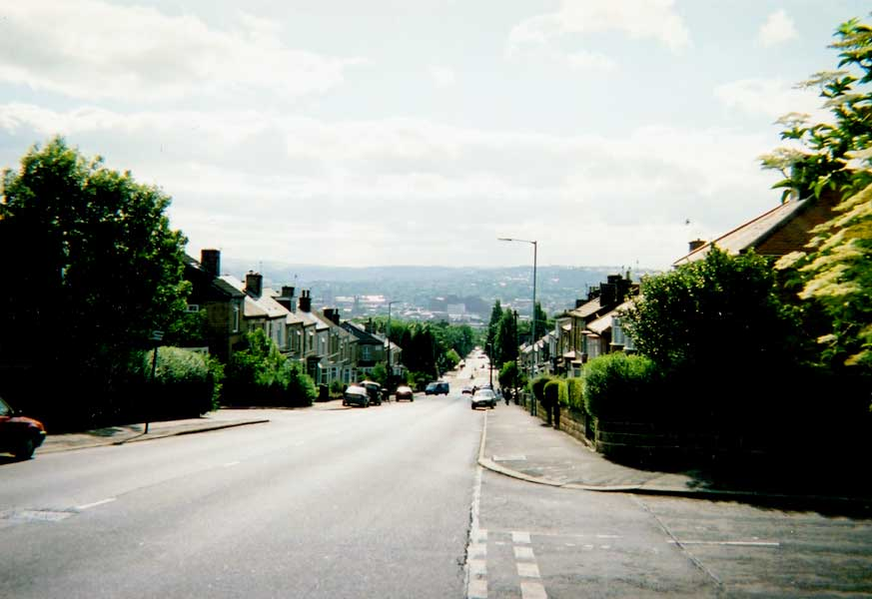  Vista of Sheffield. | 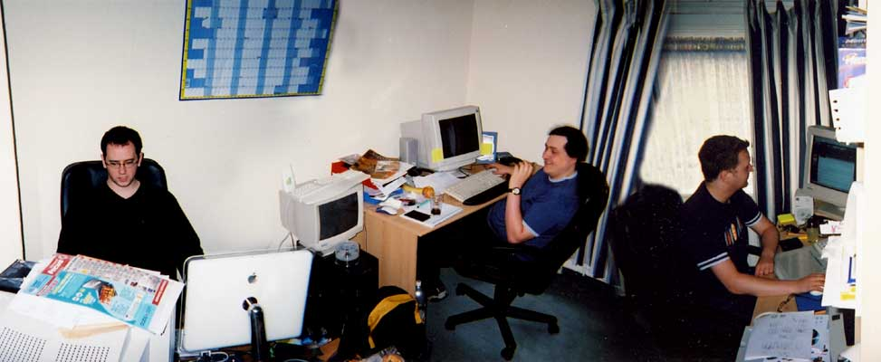  Stitched panorama of the office (AKA: The flatulence chamber). From Left> Darren aka Goober (Programming), Mark aka Fezzy (Programming), Nick aka FOST (Art)
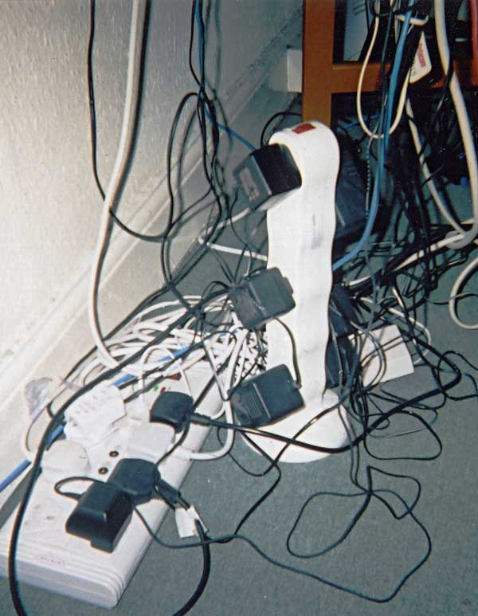  The Moonpod Power Nexus. Where did we put that fire hazard insurance? | 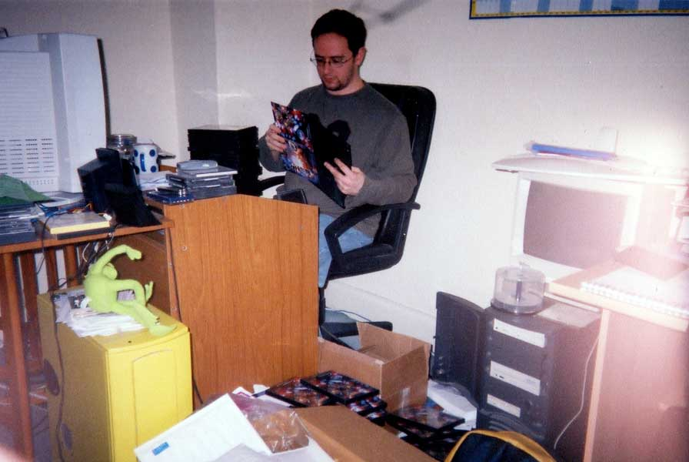  Monday morning: putting together CD-ROM cases ready for the weekly dispatches.
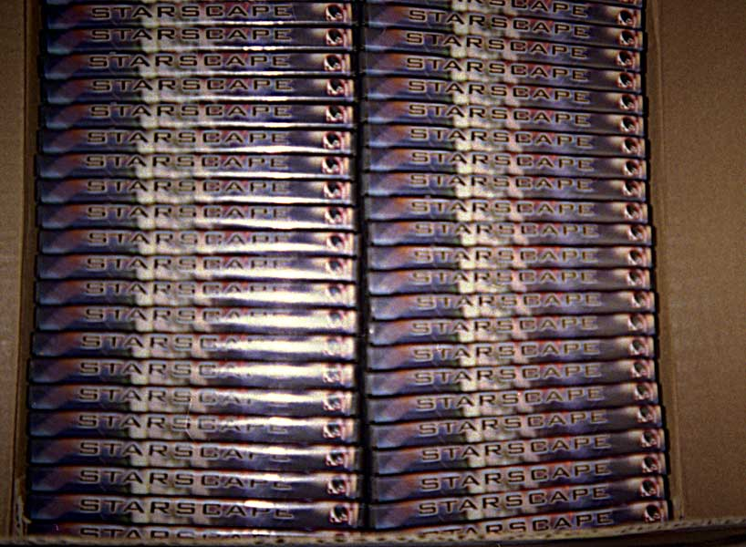  Finished Box | 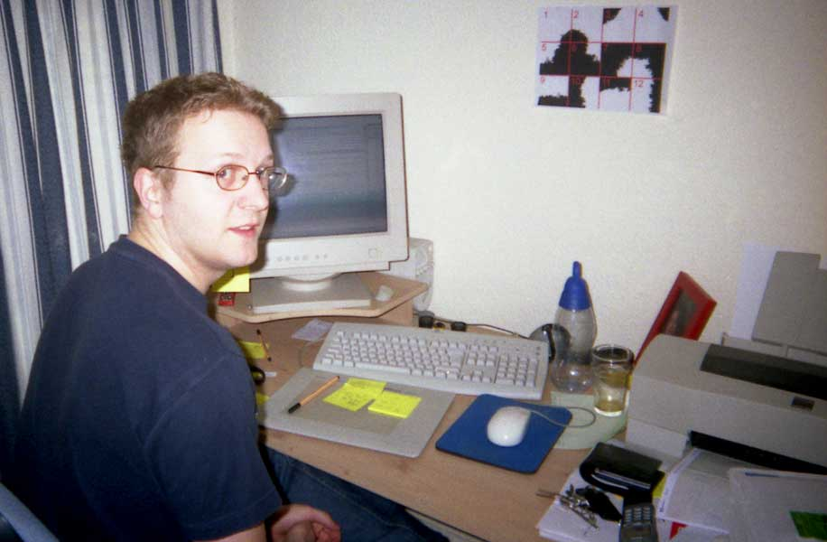  Nick at desk, caught out.
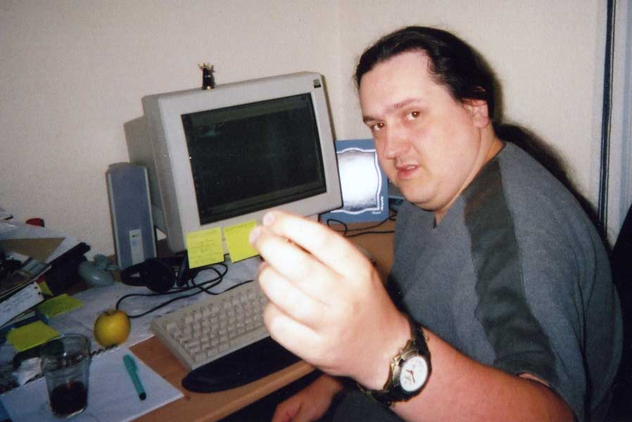  Mark at work, caught out, with apparently massive hands. | 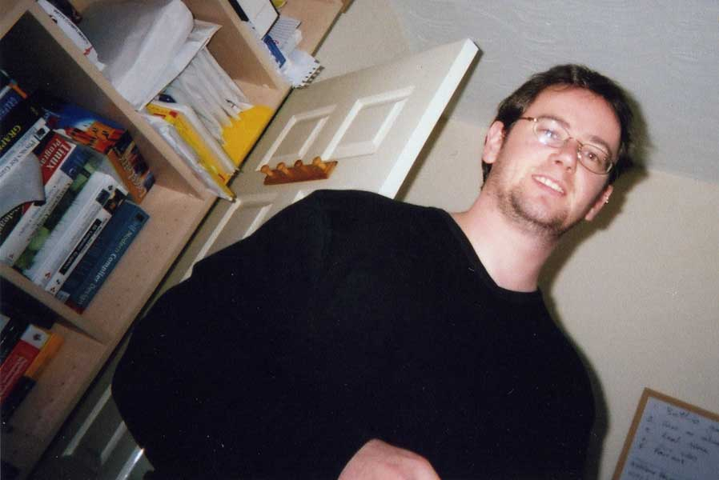  Darren caught dancing around the room.
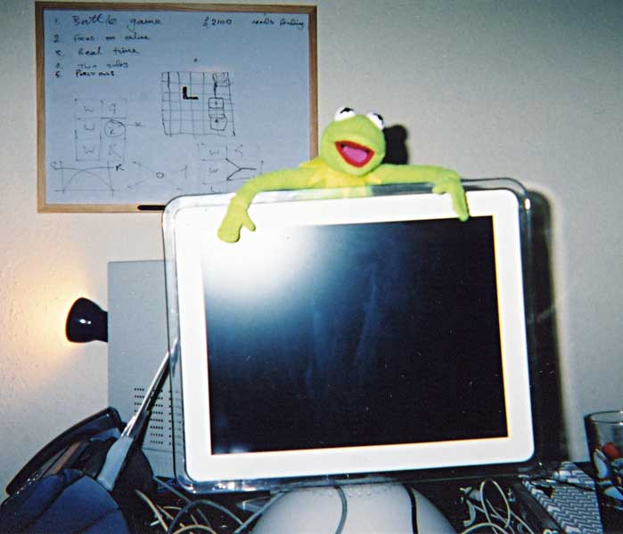  Kermit guarding the Mac (which isn't looking like it will see much action for a long time). Initial design work for our second game in the background. | 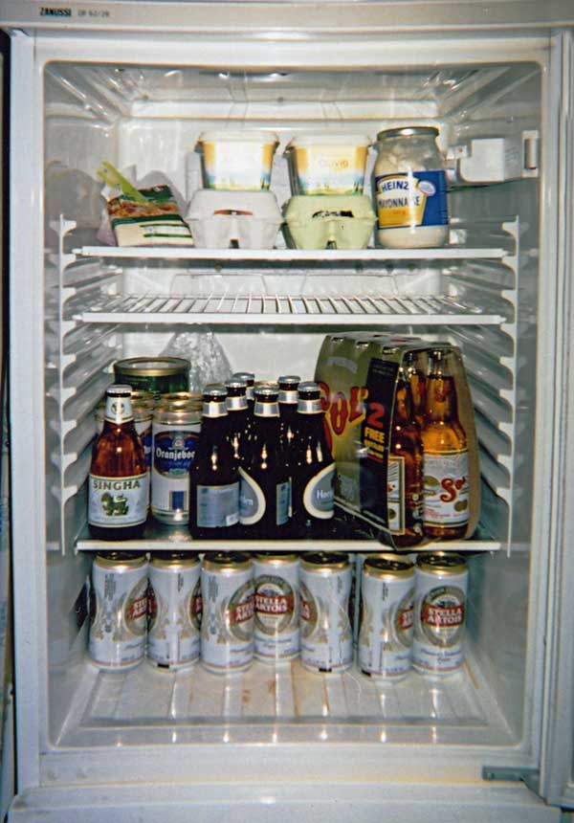  The Fridge.
  The Bin.  Must cut down on the coke. | 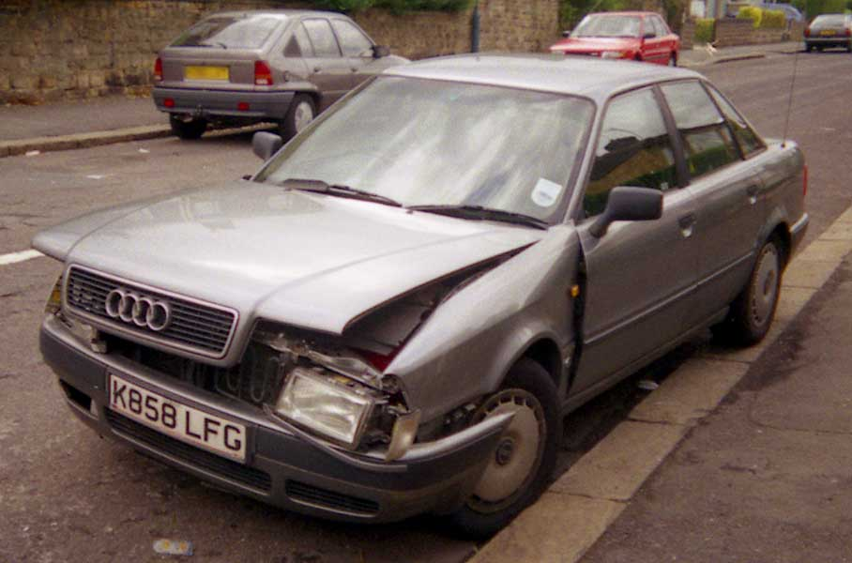  The Moonpod-Mobile gasps its last breath, now we'll have to get the train to ECTS.
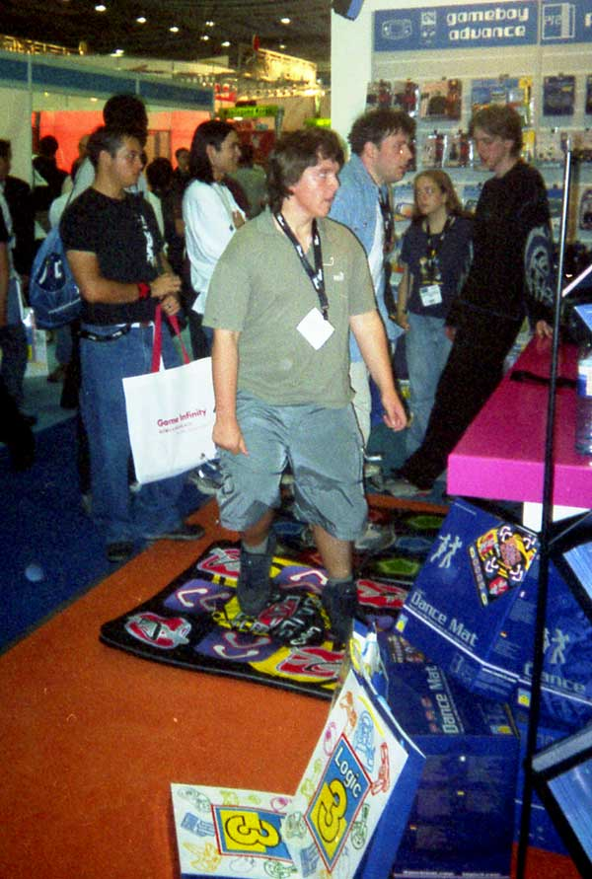  ECTS show London: A static image doesn't really get across how much of a fool this guy was making of himself. | 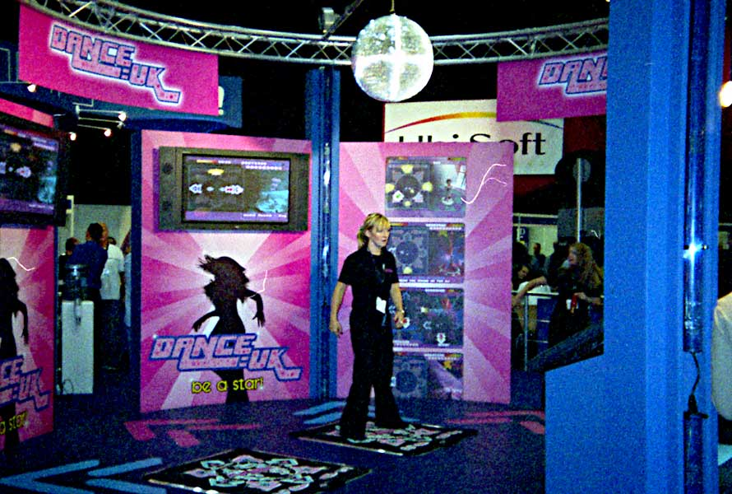  ECTS: The ladies show how it is supposed to be done.
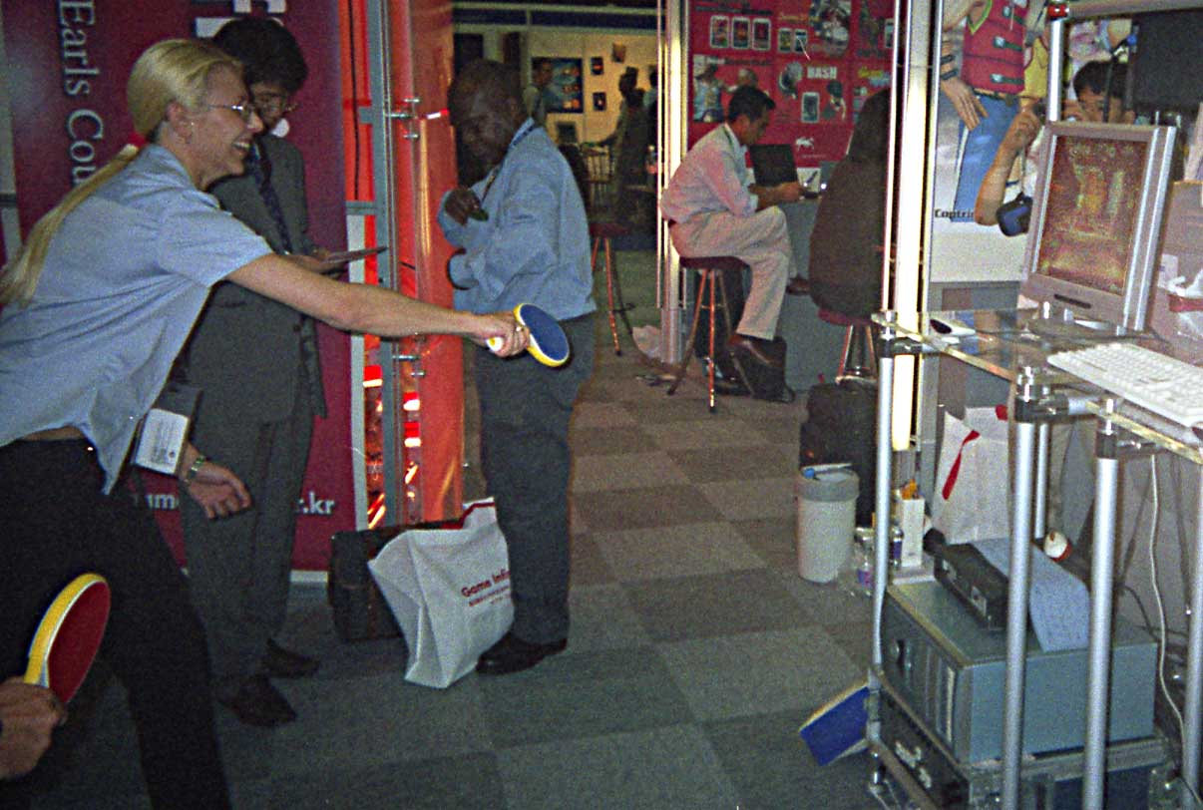  ECTS: Nothing much on the indie games front. Here's a table tennis paddle sensing game in action. | 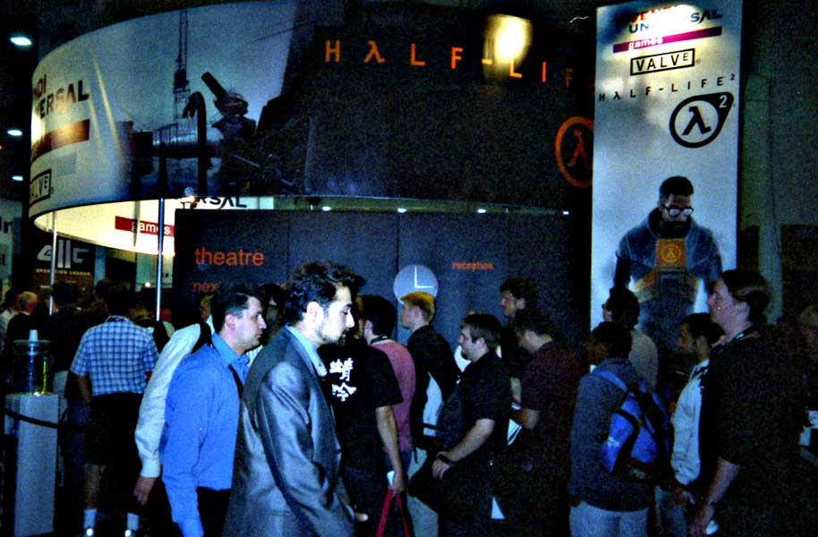  ECTS: Some game we had never heard of seemed popular. Sequel to 'Half..' something or other...
  ECTS: Mark checks out a potential replacement for his car. 'I wouldn't be so upset about the Audi if I had that...' | 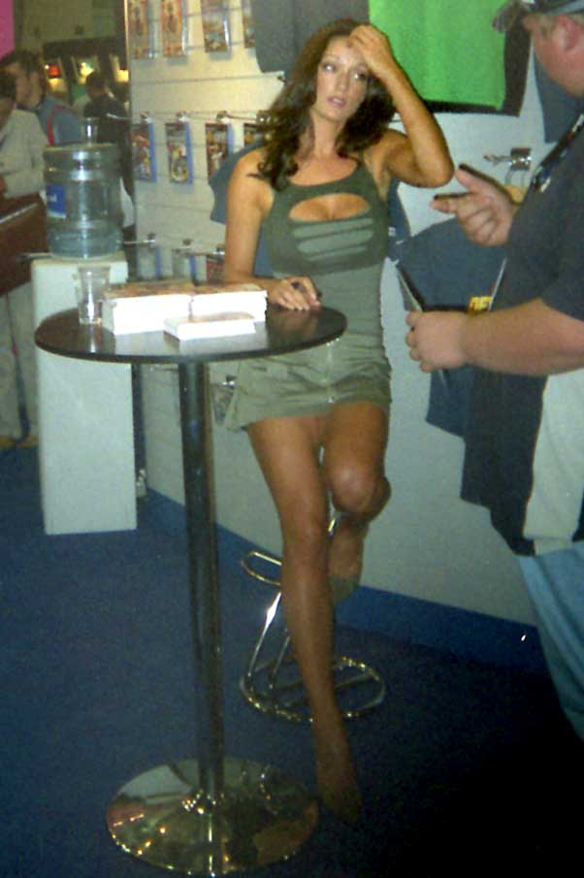  ECTS: Apparently this girl is famous and was signing autographs.
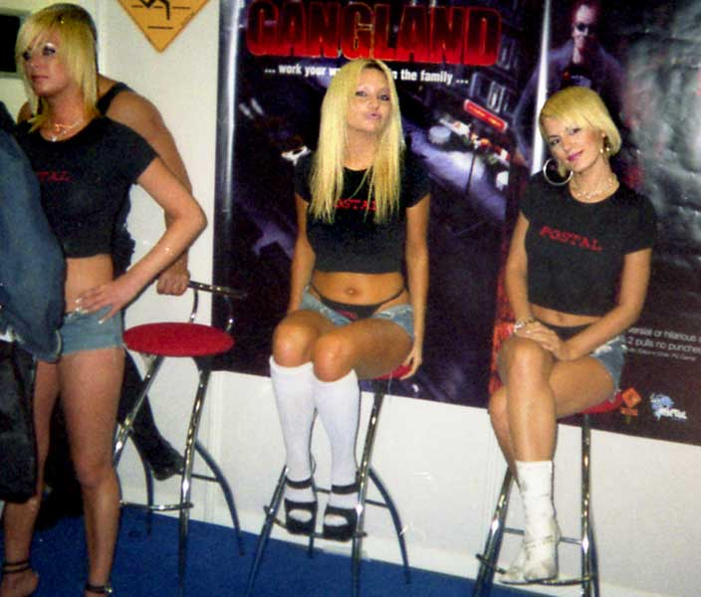  ECTS: Proving once again that it really is a poor man's E3. | 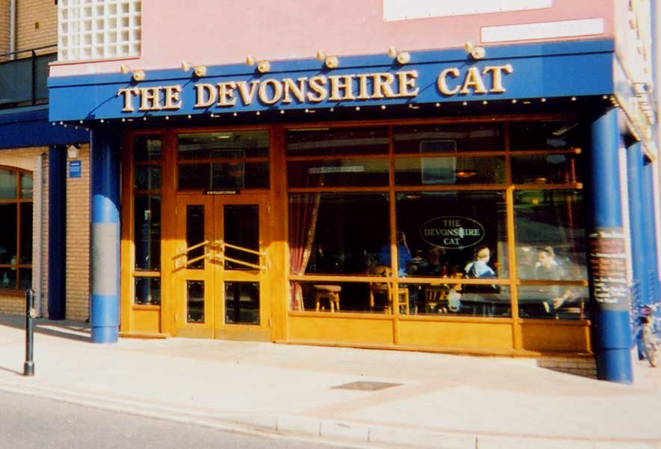  Back in Sheffield to show you some of the nightlife. Starting at: 'The Devonshire Cat'. One of the many great pubs in Sheffield. The Cat sells most beers from around the world!
  Moonpod Recommends: 'Erdinger' | 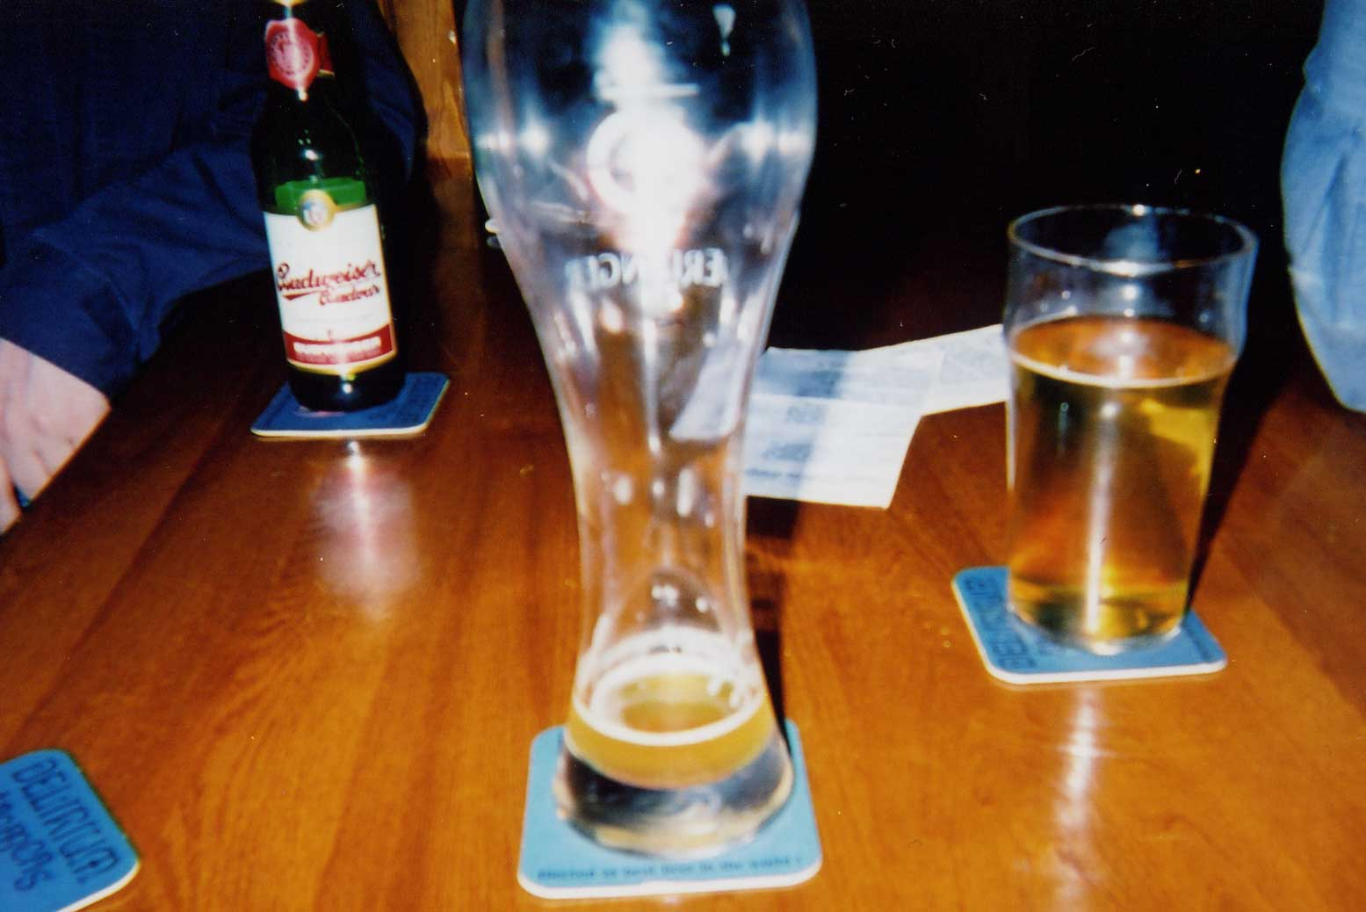  Mmmmm.
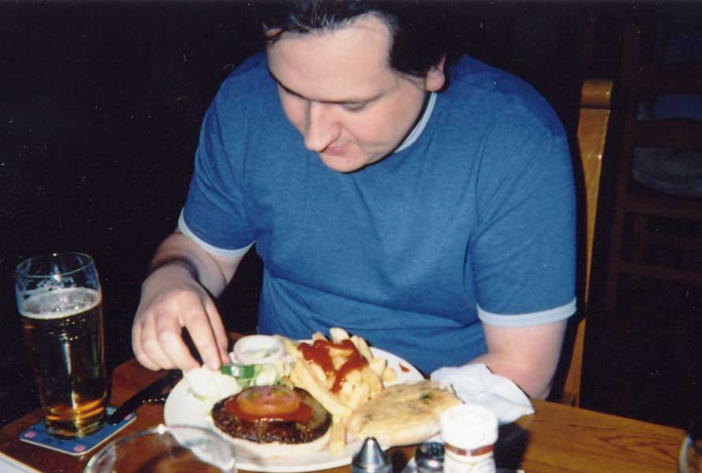  The Food is pretty good too! No animals were harmed during the making of this meal (Except a cow) | 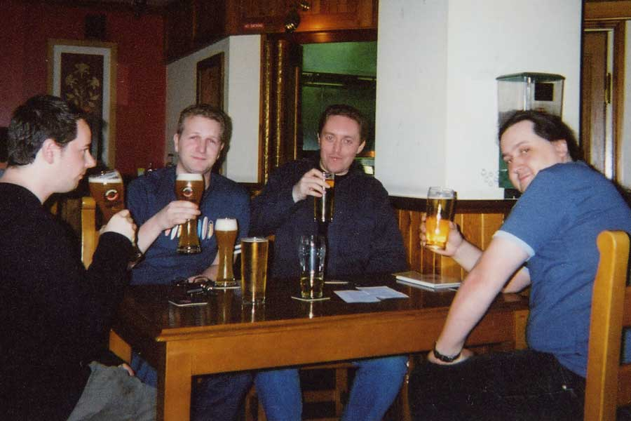  Cheers DIY Games! (Not sure who the guy middle right is, he just turned up and started drinking with us)
  Outside on the way to a club: Sheffield Girls: Common as muck. | 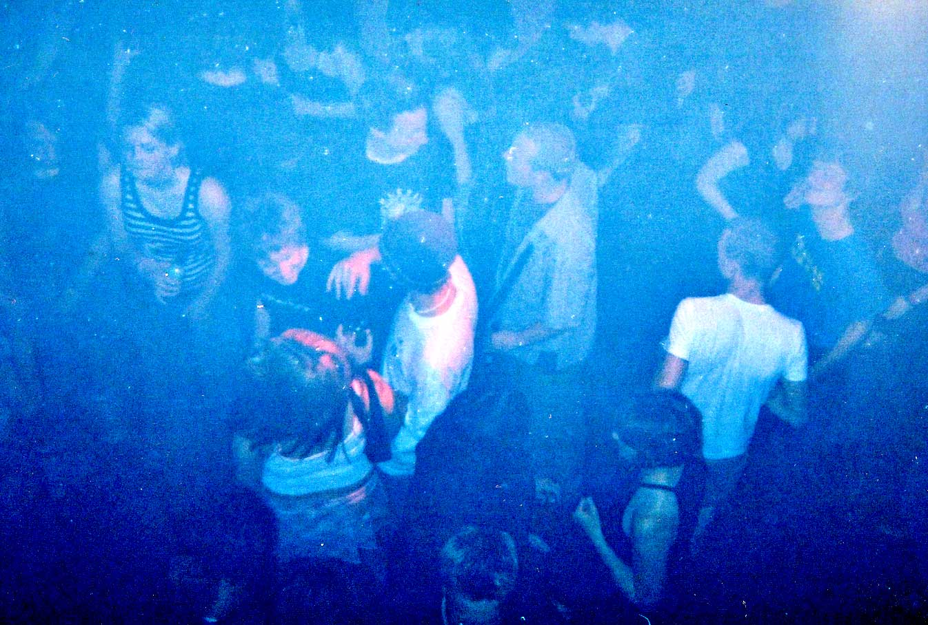  Sheffield gets down to party! No one has any idea which club this is, although we are pretty sure we were still in Sheffield at this point.
  Be Afraid... Be Very Afraid... | 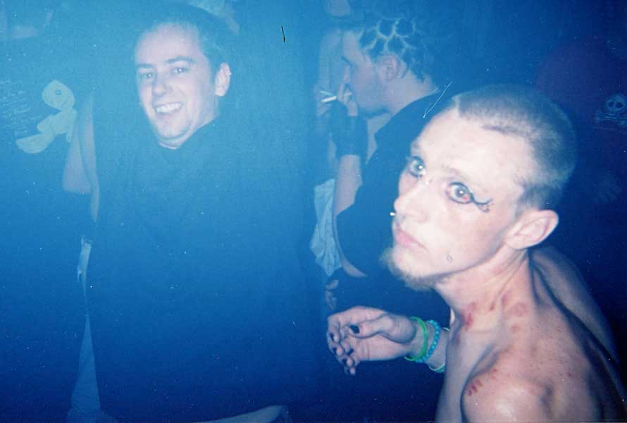  Be REALLY Afraid...
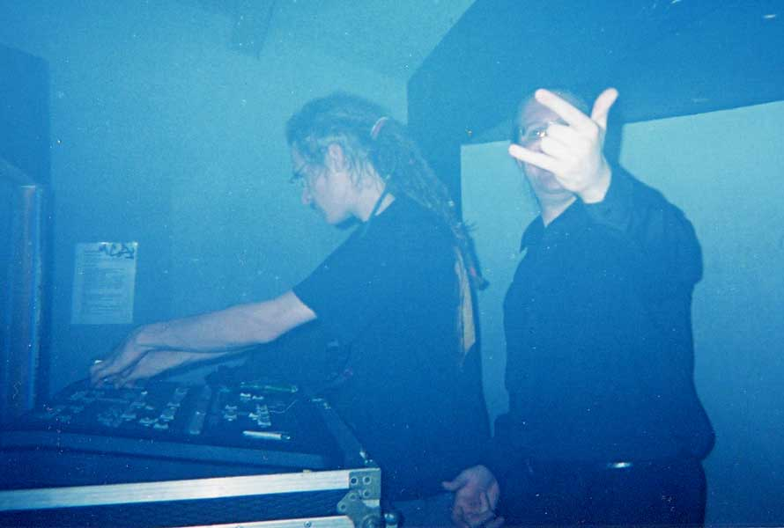  The DJ working the crowd, I think his mate is saying 'Live Long and Prosper...' |   Outside, we eventually find Darren, he seems happy, must have scored with the ladies...
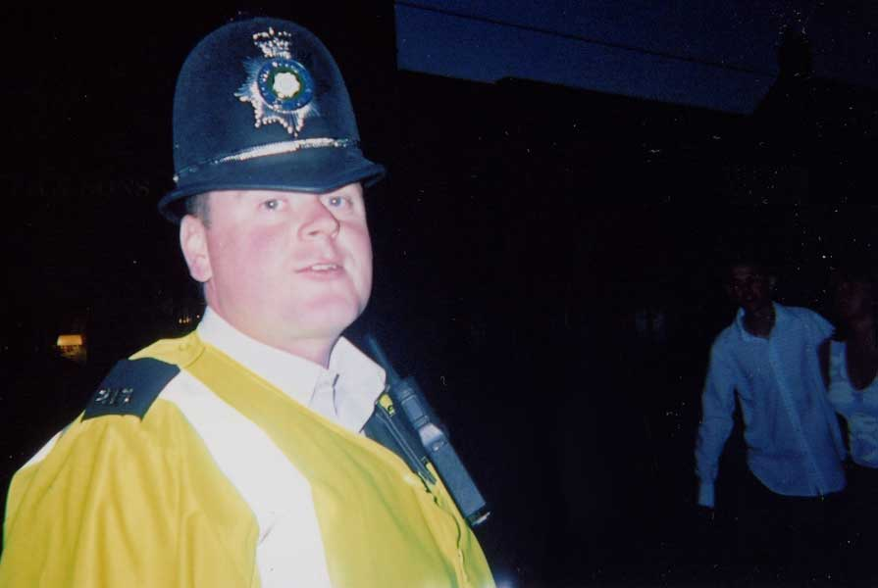
Time to go home!!

